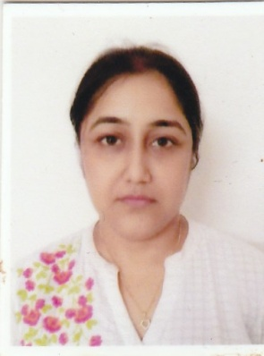
67/Mahesmati,
Malda-732101-West Bengal
Email: gouri2das@gmail.com
Mob-09775466813, 6295315060

Gouri Singha
Curriculum Vitae

Profile

Sex:-Female
Date of Birth: - 05/05/1983
Marital Status:-Married
Fathers’ Name: - Mr.Radha Raman Singha

SUMMARY
Adaptable professional with 2 Years of experience and proven knowledge of classroom management, course design, and curriculum development. An enthusiastic educator who understands students to gain physical skills and confidence for their all-round education to succeed. Looking to contribute my knowledge and skills in an institution that offers a genuine opportunity for career progression.

SKILLS
- Creativity
- Schedule Management
- Effective Communication
- Leadership
- Handling pressure
- Motivation Speaker

Educational Qualification

YEAR | EXAMINATION | BOARD/UNIVERSITY | DIV | PERCENTAGE
2002 | Madhyamik | W.B.B.S.E (WB) | 2nd | 46.25%
2004 | Higher Secondary | W.B.C.H.S.E (WB) | 2nd | 52.6%
2007 | B.A(Sociology Hons.) | NORTH BENGAL UNIVERSITY | 2nd | 43%
2009 | M.A (Environmental Studies) | RABINDRA BHARATI UNIVERSITY | 2nd | 58%

Professional Experience

1) Worked as Assistant teacher In ‘Ajit Memorial Kindergarten School’Malda for 02 years.

Co-curricular Activities

A) Computer Knowledge:-

Done ‘Office and Internet’ certificate course from George Telegraph Training Institute, Malda Centre.

B) Cultural Activity:-
Done B.Music from Sarbaharatiya Sangeet-o- Sanskriti Parisad, Kolkata

Language Known:-

English, Hindi, Bengali

Hobby:-Reading books, and listening to music

Gouri Singha
Date: - 11.10.22 Signature

