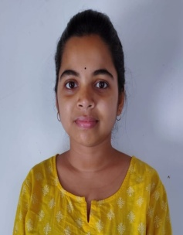
Curriculum Vitae
Name: Moumita Haldar
Date of birth: 22/08/1999
Contact No: 7797475462
Email: moumitahaldar9991@gmail.com
Address: Bamangola
Pin no:732138, Malda.
Language | Speak | Read | Write
English | Yes | Yes | Yes
Hindi | Yes | Yes | Yes
Bengali | Yes | Yes | Yes

Educational Qualifications –
Degree | Course | School/college | Year | % marks
B. Sc | General(physics  ,mathematics,  computer science) | Gour Mahavidyalaya. | 2021 | 86%
Higher secondary | Science | WBCHSE | 2018 | 63.4%
Madhyamik | --- | WBCHSE | 2016 | 75%

Declaration –
I hereby declare that all the details furnished above are true to the best of my knowledge.

