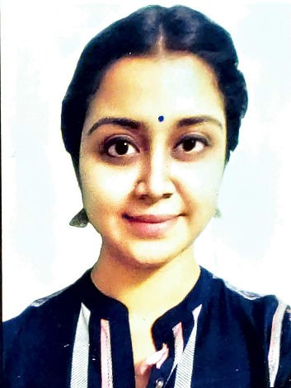PALLABI TIWARY

Email: 98pallavitiwary@gmail.com Mobile: 9163234504

Career Objective:
- To utilize my skills and provide a professional service to the institution by applying my knowledge and work in a challenging and motivating working environment.
- To inculcate moral values and virtues among learners so that they shine brightest in future.

Professional Summary:

- Worked as an intern teacher in “NATIONAL ENGLISH SCHOOL”.
- Have experience in private tutoring since 2014.
- Working at IEM PUBLIC SCHOOL.

Key Skills:

- An energetic, motivated and highly dynamic nature with excellent communication skills.
- Adaptable, engaging, empathetic and have high patience level.
- Good command over English.
- Posses all the modern method of teaching.

DEGREE | INSTITUTION | SUBJECT | YEAR | MARKS
B.Ed. | NATIONAL COLLEGE OF EDUCATION | COMMERCE | 2019-2021 | 92.45%
BACHELOR of  Commerce | CALCUTTA UNIVERSITY | FINANCIAL ACCOUNTANCY | 2016-2019 | 59.22%
All India Senior School Certificate Examination  (XII) | ST. STEPHEN'S SCHOOL | COMMERCE | 2016 | 87.5%
I.C.S. E (X) | ST. STEPHEN'S SCHOOL | ENGLISH, MATHEMATICS, SCIENCE, COMMERCIAL APPLICATION, HISTORY  &GEOGRAPHY, HINDI | 2014 | 74%

Technical Knowledge:

- Knowledge in MS OFFICE, MS EXCEL, POWER POINT PRESENTATION.
- Can easily conduct online classes with n number of students.

Extracurricular Activities:

  - I have participating in various debate competition related to my subject.
  - 17 years of dancing experience, worked as an assistant choreographer in many shows. I have acted in various dramas and have participated in inter college Drama festivals.
  - Have experience in Drama and stage shows
  - Keeps interest in sports.

Personal Details:

Date of Birth - 26/03/1998
Nationality - Indian

Correspondence Address: -

BD-203, Kamal Apartment (soleus gym building),
Keshtopur.
Kolkata - 700101.

Thanking you, Regards, Pallabi Tiwary

