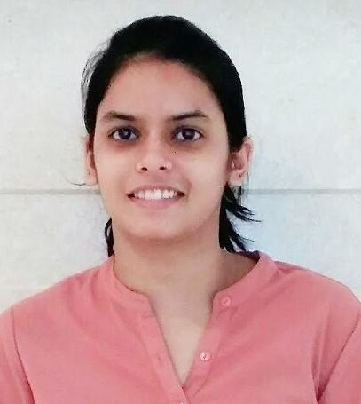
CHARUL MAHUR
D-3/40, Sangam Vihar
New Delhi-110080
Contact No.- 9811976798
Email: charulmahur03@gmail.com

Career Objective
My vision is to seek the position of Political Science/ Social Science Teacher in an organization that will give me an opportunity to pass on my knowledge to the students in an innovative manner and to the best of my abilities and foster meaningful relationships with students and school personnel.

Educational Credentials
Degree/ Certificate | School / College | University or Board | Year of |  | Percentage
Degree/ Certificate | School / College | University or Board | Entry | Leaving | Percentage
M.A. in Sociology | Akshay Pratishthan | IGNOU | 2018 | 2020 | 69.00%
B.Ed (Political Science and English) | Institute of Vocational Studies | Indraprastha University | 2017 | 2019 | 81.92%
M.A. in Political Science | Lakshmibai College | Delhi University | 2015 | 2017 | 58.6%
B.A.(H) in Political Science | Motilal Nehru College | Delhi University | 2012 | 2015 | 64.8%
Senior Secondary School | Balvantray Mehta Vidya Bhawan,GK-II | CBSE | 2011 | 2012 | 77.4%
Secondary School | Balvantray Mehta Vidya Bhawan,GK-II | CBSE | 2009 | 2010 | 74.1%

Achievements
Qualifying Exam | Qualifying year | Marks obtained  (MM-150)
Central Teacher Eligibility Test-Paper 1 | July 2019 | 111
Central Teacher Eligibility Test-Paper 2 | July 2019 | 103
NPTEL Online Certification (INTELLECTUAL PROPERTY) | April 2020 | 81%
Internship Experience

Organization | Training Tenure | Details
Hamdard Public School ,Hamdard Nagar, New Delhi | 6th August to 21st December, 2018 | Teacher training:  Political Science in 11th and English in 7th using various teaching aids

Experience
Organization | Tenure | Details
Summer Fields School, New Delhi | 9th January, 2020- till date | TGT (political science)  Teaching classes 10th, 11th and 12th

Projects
- Research paper on “Availability of audio-visual aids in government school”.

Volunteer Experience

Volunteered 5 months in Teaching at Shades of Happiness Foundation (St. Columba’s School, Ashok Place, New Delhi)

Volunteered in various Polio Campaigns

Skills

Communication skills

Interpersonal skills

Basic computer skills (MS WORD, EXCEL, POWERPOINT) and Internet Operations

Creating Blogs, Google Classrooms and E-portfolios
Extra Curricular Achievements

Participated in Delhi 2010 CommonWealth Games (Dance competition)

Won first prize in “Vivekananda Quiz”

Participated in Chinmaya Youth Festival

Been a part of Rotary Youth Club

Been a part of the Discipline Committee as the Prefect

Participated in debates and seminars

Personal Vitae
Father’s Name : Mr. Satveer Singh Mahur
Date of Birth : 21 September, 1995
Languages Known : English, Hindi
Sex : Female
Marital Status : Married
Nationality : Indian
Strengths : Positive attitude, Quick learner, Self Improvement, Focused,
Punctual, Knowledgeable and Creative.

Declaration:
I, Charul Mahur, hereby declare that all the information provided in my resume is true to the best of my knowledge.

