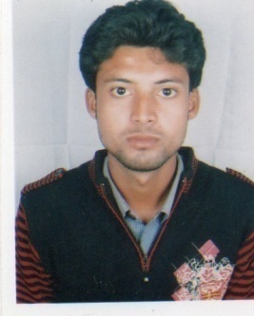
SUBAMAY SARKAR
Vill - Sonabandh, P.O + P.S - Hemtabad, Dist - Uttar Dinajpur
State-West Bengal, Pin – 733130
subhamayfacebook1993@outlook.com, Mob – 9064086023 / 8116670477

CAREER OBJECTIVE

To be associated with a progressive organization which can provide me with a dynamic work sphere to extract my inherent skills as a Professional, use and develop my aptitude to further the organization’s objectives and also attain my career targets in the progress.

QUALIFICATION AND SKILLS

Academic qualifications :
- M. Sc. In Computer and Information Science from Raiganj University.
- Bachelor In Computer Application from North Bengal University , Raiganj campus.
- H. S. from Hemtabad Adarsha Vidyalaya under West Bengal Council of Higher Secondary Education.
- M. P. from S.D.P.U.Vidyachakra under West Bengal Board of Secondary Education.
Extra qualification :
- Completed 6 month certificate course in Information Technology from Yuva Kalyan.
- Completed 6 month diploma in Tally ERP 9.
- B.Ed from Ch. Charan Singh University, Meerut ( Session 2018 – 2020 )
Academic project :
- Godown Management System based on VB ( front end ) & Microsoft Access ( back end ).
- Banking Management System based on VB.net ( front end ) & SQL server 2005 ( back end).
Experience :
- 1 year teaching experience at Hemtabad Adarsha Vidyalaya ( H.S )
- 2 year teaching experience at a computer literacy institute.
Technical skills :
- Application
  - Word
  - Exel
  - Access
  - Powerpoint
- Database technology
  - Basics of database
  - Oracle
  - My SQL
- Software technology
  - C
  - C++
  - Java
  - VB.net
  - Python
- Web technology
  - HTML
  - SEO
  - PHP

Vill - Sonabandh, P.O + P.S - Hemtabad,
Dist - Uttar Dinajpur
State-West Bengal, Pin – 733144
Date of Birth – 09-12-1993
Nationality – Indian
Language known – English, Hindi, Bengali

Date :
Place :

I hereby declare that the above statement is true to the best of my knowledge and belief, and that I understand it is made for use as evidence in court and is subject to penalty for perjury.

