Resume
RESUME

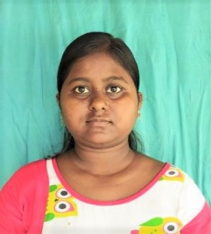
SUSMITA ROY

9933787608

Susmitaroy81846@gmail.com

College more, Islampur, Uttar Dinajpur 733202

CAREER OBJECTIVE
To have a career in a professional organization and put all my efforts into the growth of the organization and have a great working environment.
Academic Qualification
- 10th pass from WB Board in 2013
- 12th pass from WB Board in 2015
- Graduate with B.sc(Mathematics) from North Bengal University in 2019
- Post Graduation with M.sc(Mathematics) from North Bengal University in 2021
- B.ED from Baba Saheb Ambedkar Education University in 2023
Technical Qualification
- 12th month diploma in computer application
Experience
- Freshers
Personal Details
Name : Susmita Roy
Father’s Name : Late. Kartick Chandra Roy
D.O.B : 02/01/1998
Marital Status : Unmarried
P. Address : College more, Islampur, Uttar Dinajpur,
733202

Date:____________
Place:____________

