
RESUME
Subham Ghosh
Contact numbers –7584044760 and 9563928971
Email Address -- subhammalda8@gmail.com

Career objective:

To pursue a career that will enhance my education & professional qualification, which will provide ample opportunities for growth & a rewarding remuneration.

Educational qualification:

- In 2010 passed Madhyamik Examination from Mahesmati D N Saha Vidyabhaban
- In 2012 passed Higher Secondary Examination from J M S Hindi High School.
- In 2015 Graduation (B.A) under University of Gour Banga

Professional qualification:
Completed CITA, DITA, TALLY. ERP 9 course .

Computer knowledge:

Have knowledge of computer about Fundamentals, DOS, Windows, MS-Word, Ms-Excel, Visual FoxPro, Visual Basic, Access, Flow Chart, Project Work, E-mail & Internet.

Working experience: 10 years job experience

1. Worked as the Marketing in charge of Sharekhan, Stock Market for 3 years in Malda.
2. Worked as a Merchantdiser of Nestle India Pvt. Ltd for 2 years in Malda.
3. Working as Marketing in charge & Admission in charge of Usha Martin School, Malda.

Job responsibilities in Usha Martin School , Malda:
- Planning and preparing the Marketing Budget for the next academic session.
- Selecting the hoarding sites and fixing the rates.
- Selecting print media and fixing the rates.
- Providing inputs to the design of the advertisement contents in flex, print media, brochures, folders etc.
- Careful execution of the plan as per timeline.
- Monitoring office staff involved in marketing.
- Replying to online queries and walk-ins.
- Selling the Prospectus.
- Fixing the Admission Test Date and getting the answer script corrected by subject teachers.
- Fixing the appointment for interaction with the Dean or the Principal.
- Completion of admission procedure by handing over the approved Admission Form to Accounts Department with necessary documents as per CBSE guidelines.
- Facilitating the parents of the newly admitted students to get the books, copies and uniform from the Books in charge and Dress in charge.
- Explaining the parents of the newly admitted students about the bus routes and stoppages.
- Coordinating with Transport in charge for creation of new stoppages within existing routes or creation of new routes in potential areas.
- Collecting feedback after PTM.
- Sending bulk SMS as per instruction from the Dean/ the Principal.
- Tele-calling for depositing pending school fees as per Due List from Accounts Department.
- Helping to organize the various “utsavs” in school as part of school curriculum- Rabindra Utsav (May), Mango Utsav (Utsav), Prakriti Utsav (July), Swadesh Utsav (August), Jantra Utsav (Sept), Ananda Utsav (Nov), Bhoj Utsav (Dec), Urja Utsav (Jan) and Basanta Utsav (March).
- Coordinating with Accounts Department to deposit cash and cheques in the bank.
- Coordinating with Books & Dress In-charge to collect them from the transport, to reconcile with the list and finally uploading the same in Tally.
- Purchasing items for the school as per approval.
- Helping IT Support Team to co-ordinate with parents in solving difficulties arising while executing the online teaching content for the children.
- Maintaining a record of the names of the students with their phone numbers and e-mail ids.
- Helping during TC formalities when students leave school.
- Maintaining Drop Out List with reason for future use.
- Facilitating payments to various vendors as per instruction from management.

Personal Details:
Date of birth: 15.01.1995
Nationality : Indian
Marital status: Married
Language Proficiency: English, Bengali and Hindi.
Permanent address:
S/O Late Gopal Ghosh
P.O. & Dist. - Malda
Pin code – 732101

Declaration: I hereby declare that all statement made in this resume are true complete & correct the best of my knowledge & belief.

Place :- Malda

Date :-
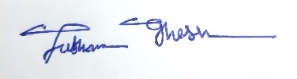
………………………………..
Signature

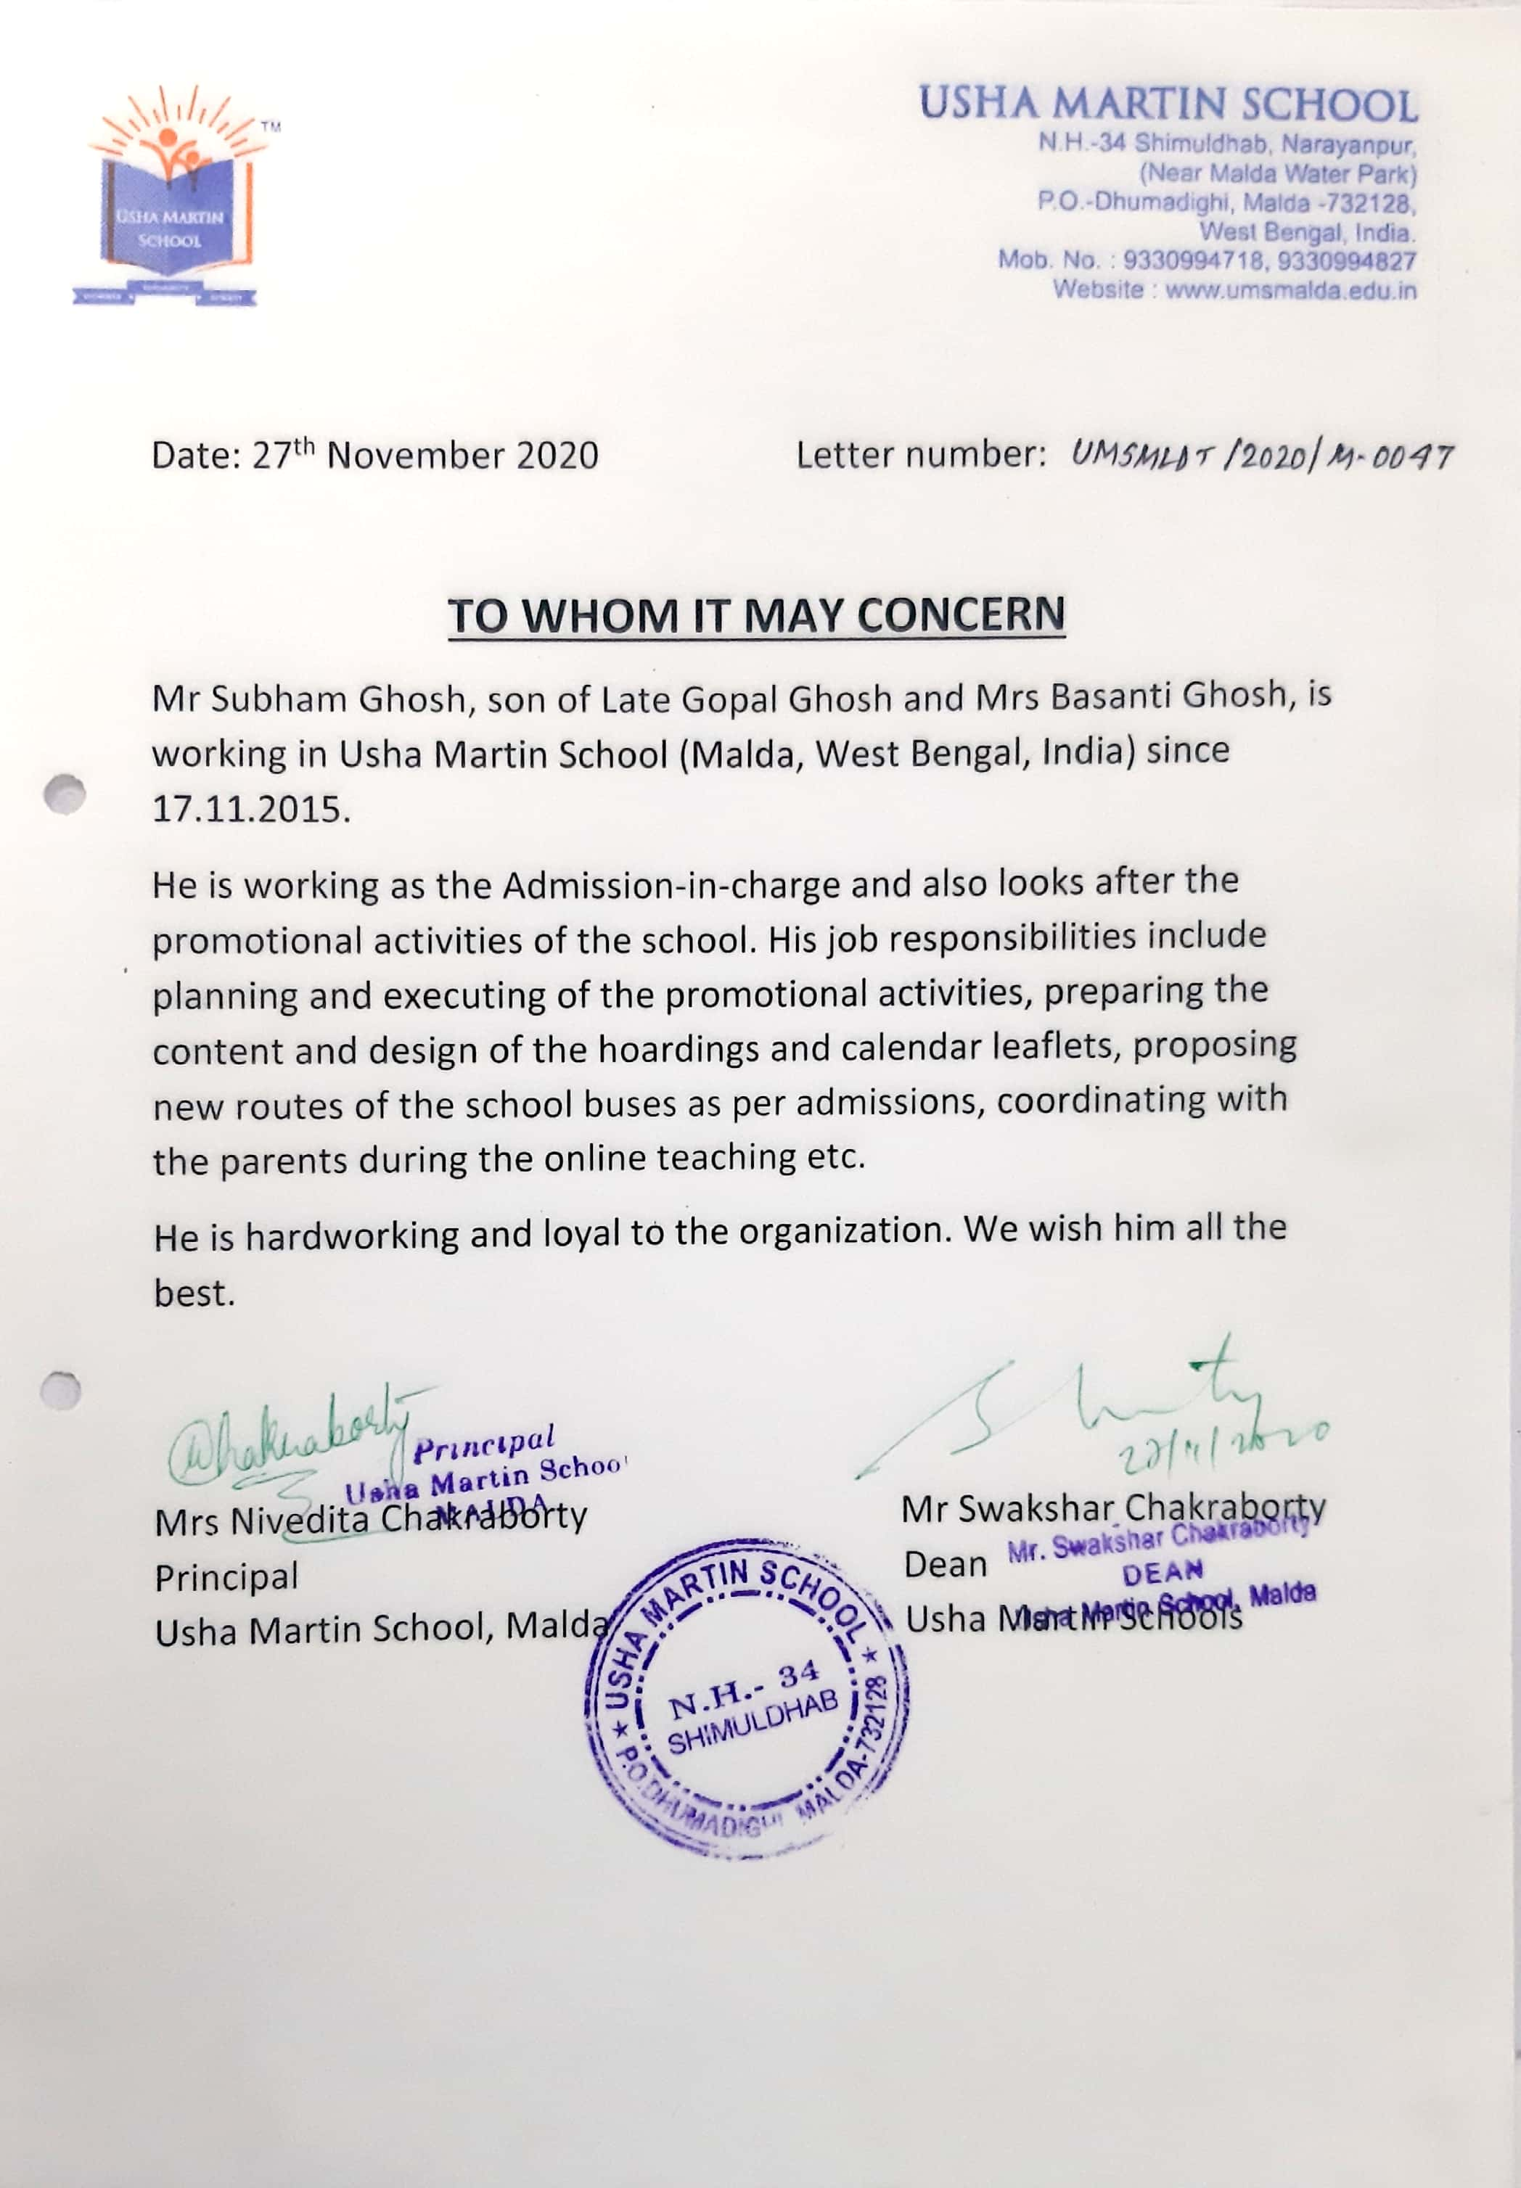
Experience Certificate

