CURRICULUM VITAE

Name: Ayusree Sen
9064300351
✉️ayushreesen2000@gmail.com (Personal)

CAREER OBJECTIVES:
To work for an organization which provides me the opportunity to learn, improve my skills and also to align myself with the overall growth of the organization.
ACADEMIC QUALIFICATIONS:
DEGREE/CERTIFICATE | INSTITUTE | BOARD/UNIVERSITY | YEAR OF PASSING | GRADE
B.Ed | ACC JAIN COLLEGE OF EDUCATION | WBUTTEPA | Pursuing
BSC Zoology (H) | ABHEDANANDA MAAVIDYLAYA | BURDWAN UNIVERSITY | 2021 | A
12th | SAINTHIA HIGH SCHOOL | WBCHSE | 2018 | A
10th | SAINTHIA JOGESWARI DUTTA GIRL'S HIGH SCHOOL | WBBSE | 2016 | A

TECHNICAL STRENGTHS:
- Microsoft office
- Tally and GST
STRENGTHS:
- Confident and Optimistic
- Hardworking and Quick learner
- Flexible to work under any environment
- Enthusiastic on taking new challenges
WORK EXPERIENCE:
- SAINTHIA HIGH SCHOOL
01-09-2022-22-02-2023 As a Trainne Graduate Teacher
PERSONAL PROFILE:

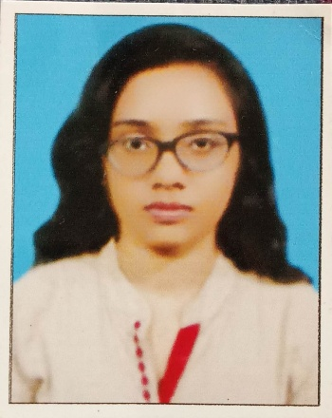
NAME: AYUSREE SEN
NAJRUL SARANI
SAINTHIA BIRBHUM
WEST BENGAL
PIN-731234
FATHER’S NAME: ASHOK KUMAR SEN
MOTHER ’S NAME: SAMPA SEN
DATE OF BIRTH: 14^{th OCTOBER} 2000
HOBBBIES: Travelling, Photography and Doing Online Courses on various subjects.
LANGUAGE KNOWN: ENGLISH, HINDI AND BENGALI (Read, Write and Speak)

