Smita kumari
. 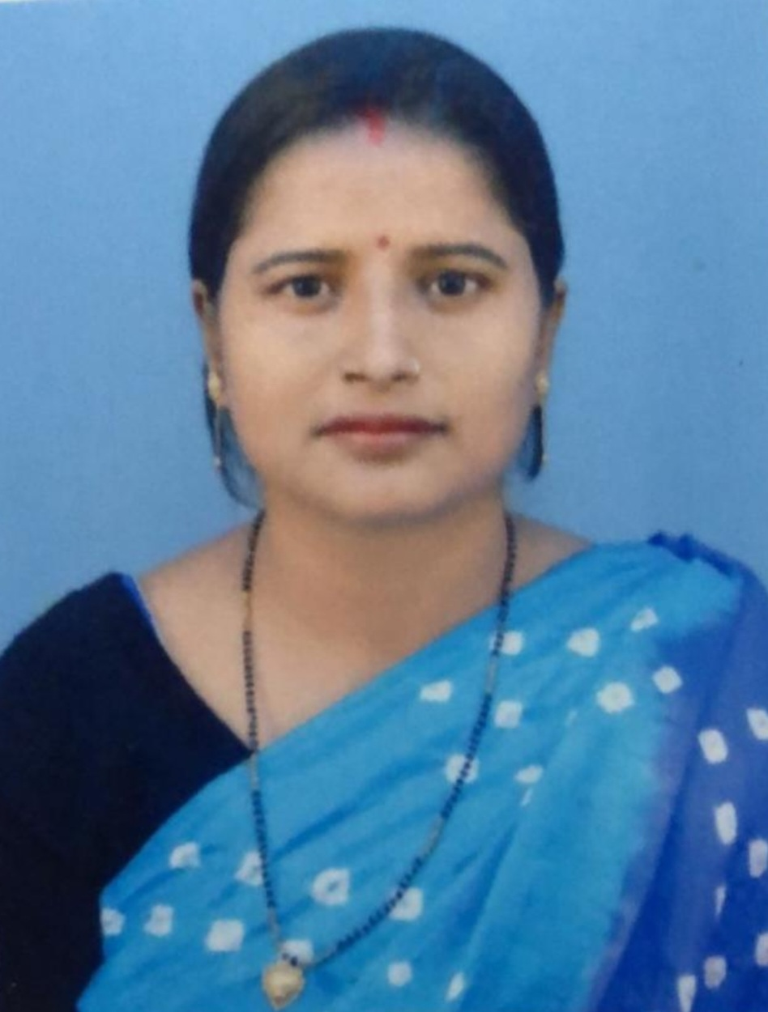
E-mail : smitaprakashvaibhav@gmail.com
Mobile: -8409219475
CAREER OBJECTIVE

Intend to build a career with growth oriented organization with committed & dedicated people, which will help me to explore myself fully and realize my potential. Willing to work as a key player in challenging & creative environment.
SYNOPSIS

- About 08 years of Teaching/Parenting experience of School.
- Organized and driven with the ability to stay on task and efficient methods of teaching whilst focusing on the individual needs of each student.
- Lesson Planning Expertise
- Class management
ORGANISATIONAL DETAILS

Currently Teaching at ACHARYA SUDARSHAN KRISHNA NIKETAN (Affiliated to CBSE upto +2) as a PRT at Transport Nagar, Bypass Road, Patna from 16th may 2021 to Till Date.

PREVIOUS ORGANISATIONAL DETAILS

Since 02nd May 2018 to 31st December 2020 with St. josheph high school (Affiliated to CBSE upto +2) as a Prt at Bhootnath ,Patna .

Since 13 th April 2006 to 30 th April 2011 with English central school (affiliated to cbse ) as a Prt at sighs Patna

Job Profile:
- Teaching with Caring.
- Academic Performance Evaluations.

ACADEMIC QUALIFICATION

10th (2001) B.S.E.B from Rabindra balika vidyalaya , Patna.

12^{th (2003)} B.S.E.b (Patna university)B. N. College, Patna .

B.A (2007) FROM D.D.E UNDER Patna UniverSity , Patna .

M.A. (2016) from Nalanda open university, Patna

B.ed. (2018) from Magadh university, Gaya

PERSONAL DETAILS

Date of birth : 20 th march 1986

Present address : C/o Ashok Singh
Mokama house, opp of hanuman mandir
Bazar samiti road, Patna 800016

Husband name :Mr.Prakash Ranjan

Sex : Female

Marital status : married

Languages known : English, Hindi & local language.

Nationality : Indian

Declaration:
In hereby declare that the information furnished above is true to the best of my knowledge.

Date : 10.10.22
Place: Patna (Smita kumari )

