HILARIUS Hasda | Address:  Barovita, Post: Baidara, P.S: Itahar, District: North Dinajpur  West Bengal -PIN.733128, India  Contact No. 9932508754  Email: hila0779@gmail.com  Phone  Email  LinkedIn Profile  Twitter/Blog/Portfolio

Objective
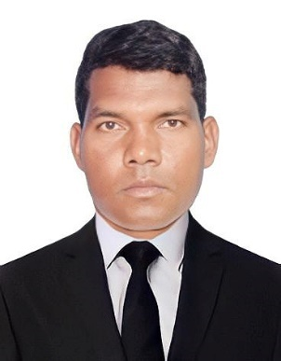
To be an asset to the organization by giving my best for the overall growth of organization with complete dedication and a spirit of team work as well as individual.To use my talent, skills, abilities and potentials for the growth of the organization.

Education

DOAEP | AKNYC

Dates From – 2020
Basic course in Tally

GRADUATION | CALCUTTA UNIVERSITY

Dates From – 2003 TO 2005
Bachelor of Arts

Higher Secondary | WBCHSE

Dates From – 2001
Arts
Madhyamik| WBBSE

Dates From – 1998
General stream

Experience

As a supervisor and accountant | Social Welfare Institute, Raiganj (NGO)

As a Computer Teacher in Bhakti Bhushan Institute, Malda
Dates from – 2018
As an Account Receivable Supervisor in Raddison Blu Hotel, Oman, Muscat .
From -May – 2023 to till date.

Professional Experience
- MS Word, MS Excel, MS Power Point
- Tally ERP.9
- Awareness programme to Children/ youth/ People
- Good at in team work
- Monitoring Team and Evaluation
- Supervising the project work
- Social development project implementation and completion and reporting.
- Inventory and stock management of solar project.
- Manage inventory levels of all supplies solar equipment
- Coordinate with vendors and suppliers to ensure timely delivery of supplies
- Ensure accuracy of inventory records and conduct regular audits
- Conduct physical inventory counts and reconcile discrepancies
- Collaborate with other departments to optimize inventory levels and reduce waste
- Catalog new inventory and update the database
- Order new inventory from book supply companies
Skills

- Excellent organizational and time management skills
- Strong attention to detail and accuracy
- Knowledge of inventory management software
- Ability to work well in a team environment
- Effective communication and interpersonal skills
- Proficient in Microsoft Office Suite

Activities
- Monitoring team in the working areas systematically.
- Taking eager initiative towards the growth of Institution.
- Leading the team to extra activities specially to keep institution neat and clean.
- Actively participating in different social works
- Keeping objects in order and neat and clean
- Taking active part in helping needy.

Personal information
Name: HILARIUS HASDA
Father’s Name: Late. Mr. NORESH HASDA
Date of Birth: 5th July 1979
Place of Birth: Barovita
Sex: Male
Marital Status: Married

Address:
Barovita, P.O – Baidara, P.S- Itahar, Dist- North Dinajpur
Pin – 733128, West Bengal, India
Nationality: INDIAN
Religion: Christian – Roman Catholic
Cast: Santal (Schedule Tribe)

DECLARATION
I do hereby declare that the information furnished above is true to the best of my knowledge.

Languages known- English, Hindi, Bengali

Hilarius Hasda
Place: Barovita
Date: 30/03/2024

