CURRICULUM VITAE
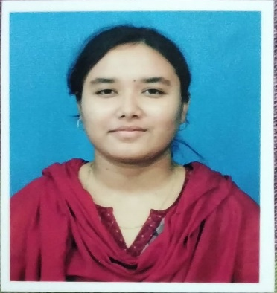
RAIHANA PERVEEN

M.A. HONS IN ENGLISH Soleman Biswasspara,Vill+P.O Sujapur, P.S. Kaliachak, Dist- Malda. Pin-732206 raihana.perveen24@gmail.com Mob No :( +91)6291357837
(+91)7384433833

CAREER OBJECTIVE
To work innovatively in an environment of challenge and growth, gain valuable experience, expertise in the area of operation as provided by the organization.

EDUCATIONAL QUALIFICATION

DEGREE | INSTITUTION / BOARD / UNIVERSITY | PERCENTAGE/CGPA  EXCEPT OPTIONAL SUBJECTS | YEAR OF PASSING
Secondary  Examination | Kendriya Vidyalaya NO.1 DHANBAD JHARKHAND  (CBSE) | 8.2 CGPA | 2013
Higher  Secondary Examination | Kendriya Vidyalaya NO.1  DHANBAD JHARKHAND (CBSE) | 66.80 | 2015
B.A. Hons In English | INDIRA GANDHI NATIONAL OPEN UNIVERSITY (IGNOU) | 55.00 | 2018
M.A Hons In English | INDIRA GANDHI NATIONAL OPEN UNIVERSITY (IGNOU) | 53.00 | 2021
B.ED  (TEACHING COURSE) | KALIACHAK SULTANA COLLEGE OF EDUCATION (BABA SAHEB AMBEDKAR UNIVERSITY) | _ | PURSUING

CTET Paper - I Qualified - 57%

  - Basic Knowledge Of Computer Application

EXTRACURRICULAR ACTIVITY : Sports and drawing.
STRENGTH : Able to work with minimal supervision, Ability to master new skills quickly.

ACHIEVEMENTS : Participated in sports event and won prizes in schools. HOBBIES : Drawing, Listening to Music, Travelling

PERSONAL PROFILE

NAME:  DATE OF BIRTH:  FATHER’S NAME: SEX:  MARITAL STATUS: LANGUAGES KNOWN:  NATIONALITY: PERMANENT ADDRESS: | Raihana Perveen  15/03/1998 MD. Abdur Rouf Female  Married  English, Hindi, Bengali Indian  Vill + PO – Sujapur, P.S. Kaliachak  Dist –Malda. PIN - 732206,  West Bengal (India)

DECLARATION:
I do hereby declare that the above particulars are true to the best of my knowledge and belief and I would be glad to provide any other necessary information.

Date: ------------------------------------- Raihana Perveen

