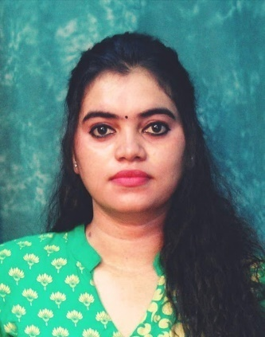

Maris Jana Daniel`
G2 hari hana apartment, ground floor
Wahab st, choolaimudu
Phone: 7550103404/9884543804
Email: dmarisjana@gmail.com

CAREER OBJECTIVE:
To work as a Montessori teacher and serve as a guide and mentor for children and to help them build confidence by engaging them in fun and practical activities.

SUMMARY OF SKILLS:
- Excellent knowledge of Mother Montessori style of teaching
- Thorough knowledge of children's growing needs
- Full of enthusiasm and brimming with new ideas for teaching children
- Ability to guide and assist children learn new things daily
- Skilled in keeping record and tracking progress in children
- Mature and professional in building rapport with children, parents, and staff.
WORK EXPERIENCE:
COMPANY | DESIGNATION | YEAR EXPERIENCE
The Nature School | Teaching faculty | 2016
Joy kids school | Teaching faculty | 2018-2019
Geetha matriculation hr sec school | Teaching faculty | 2019-2020
MKM matriculation hr sec school | Teaching faculty | 2020-2022
St,. Michael's academy | Teaching faculty | 2022-2023
EDUCATION:
UNIVERSITY | COURSE | YEAR
Patrician college of art and science | B.Sc. Visual communication | 2009-2012
SRM University | M.A journalism & mass communication | 2012-2014
2014-2016
Sri Venkateswara Montessori Teachers Training School | FICS UK (Forum for International Certified Scholar) | 2018-2019
SKILL:
Language
English | Read | Write |  | Speak
Tamil | Read | Write |  | Speak
Mayalam | - | - |  | Speak
SOFTWARE:
S.no | Software | Level of competency
1. | Adobe Illustration | Good
2. | Auto Photoshop | Good
3. | Web designing | Good
ADDITIONAL COURSE
- Graphic Designer
- Photographer
- Handcraft makes
- Jeweler designing
- Interior designing

EXTRACURRICULAR ACTIVITIES:
- Playing Games, Bharatanatyam, Reading books, Listening music, Ads editing & Art and craft .
- ATHLETIC 100mt (State), THROW BALL (National)

PERSONAL DETAILS:
- NAME. : MARIS JANA DANIEL
- DATE OF BIRTH. : 21/11/1989
- FATHER NAME. : AUGUSTINE S SINDHATHUARI

- MOTHER NAME. : MARY RAJILLA

- LANGUAGES KNOWN. : ENGLISH & TAMIL
- NATIONALITY : INDIAN
- MARITAL STATUS TAMIL & : MARRIED
Thanking you
Maris Jana Daniel
Place: Chennai.

