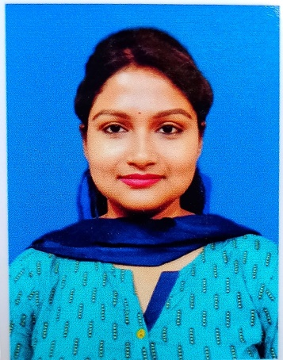
RESUME

NAME : JOYEETA BOSE

PERMANENT : H/O Pramit Ghosh
ADDRESS Madhabnagar, Neemtala
Near Badalmoni High School,
P.O- Mokdumpur, Dist- Malda,
Pin- 732103
Contact No.: (+91)9775493188 / 7001801677(M)
E-Mail – joyeebose2609@gmail.com

OBJECTIVE:
To strive hard with the best of my abilities in all segments like skill, acumen and knowledge to turn out an organization, I am attached to, into a shape that will bring sound results in view of global approach.

ACADEMIC QUALIFICATION:

Type of Exam | Board of Examination | Stream/Subject | Organisation from which passed | Year of Passing | Percentage of Marks
10th or ICSE | Council for Indian School Certificate Examinations |  | Lincoln’s High School, Siliguri, Darjeeling. | 2009 | 65%
12th or ISC | Council for Indian School Certificate Examinations. | Humanities | Holy Child English Academy, Malda. | 2011 | 86%
Graduation | Indira Gandhi National Open University | English | Indira Gandhi National Open University | 2018 | 68.42%
Post Graduation | Indira Gandhi National Open University | English | Indira Gandhi National Open University | 2021 | 63%

COMPUTER PROFICIENCY:
- Pursued Diploma in Computer Applications from BCES, Malda.

WORK EXPERIENCE:
- Worked at Logimark Services Private Limited as a Business Development Executive, from January 2014 to June 2014.
- Worked as a Part time teacher (temporary basis) of English at Sibani Academy (H.S.) Malda from September 2018- December 2018.

SOFT SKILLS:
- Interpersonal Coordination, Team Work, Public relation.
- Languages known: English, Hindi, Bengali.

HOBBIES:
- Reading news paper, magazines and story books.
- Surfing internet for up-to date news.
- Listening Music, cooking.

PERSONAL PROFILE:
DATE OF BIRTH: 26th September, 1993.
AGE: 28 Years.
SEX: Female.
NATIONALITY: Indian.
MARITAL STATUS: Married.

DECLARATION:
I hereby assure you that all above given information are true to the best of my knowledge & belief.

Date:
Place: Signature:

(JOYEETA BOSE)

