Curriculum Vitae
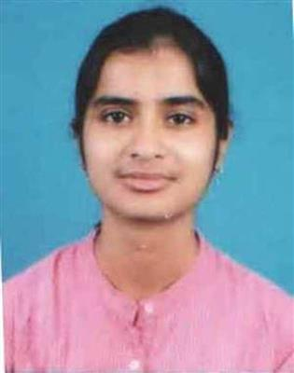
- Name:- NILANJANA GHATAK
- Email:-nilanjanaghatak3@gmail.com
- Phone:- 7059564895, 7278186630
- Date of Birth:- 11/12/1992
- Objective:- To obtain a position in an organization where I can gain work experience and can maximize my technical skills by effective learning and can input all my intelligence to the bottom line.

EXPERIENCE

- Worked for Three(3) months in STEM WORLD SCHOOL, ICSE, BARRACKPORE
- PRACTICE TEACHING in an ICSE AND NSDC affiliated school-RABINDRA PATH BHAVAN.
- One(1) month INTERNSHIP in ASSEMBLY OF ANGELS SECONDARY SCHOOL, ICSE, BARRACPORE.
- Three(3)month INTERNSHIP in SACRED HEART DAY HIGH SCHOOL(H.S)

PROFESSIONAL QUALIFICATION

- MONTESSORI TEACHER’S TRAINING (MTT): I have completed 1 year of Montessori Pre-Primary and Primary Teachers Training (JULY 2017-JULY2018) at RABINDRA PATH BHAVAN TEACHERS’ TRAINING AND CHILD RESEARCH INSTITUTION and I passed out successfully with FIRST DIVISION.

- BACHALORS OF EDUCATION (B.ED):

Degree | Semester | Institute |  | University | Year |  | SGPA |  | Percentage
B.Ed | I | Adamas School Of Education |  | Adamas University | 2018 |  | 8.95 |  | 82%
B.Ed | II | Adamas School Of Education |  | Adamas University | 2019 |  | 9.15 |  | 84%
B.Ed | III | Adamas School Of Education |  | Adamas University | 2019-20 |  | 8.95 |  | 82%
B.Ed | IV | Adamas School Of Education |  | Adamas University | 2020 |  | 9.25 |  | 85%
Total |  |  | TOTAL MARKS |  |  | MARKS OBTAINED |  | Percentage
 |  |  | 2000 |  |  | 1705 |  | 85.25%

ACADEMIC QUALIFICATION

Standard | Board/ University | School/ College | Subjects | Marks
Secondary  (Madhyamik) | ICSE | JULIEN DAY SCHOOL | English, Bengali, Maths, Science, History, Geography, Home Science and E.V.S | 82.4%
Higher Secondary | ISC | JULIEN DAY SCHOOL | English, Bengali,  Political Science,  Geography, Economics,  Home  Science, E.V.S | 80.04%
B.A (Hons) | Calcutta University | MAULANA AZAD COLLEGE | HISTORY HONOURS | 53.6%
M.A | IGNOU(INDIRA GANDHI NATIONAL OPEN UNIVERSITY) | BHAIRAB GANGULY COLLEGE | HISTORY  (MAH) | PURSUING

COMPUTER PROFICIENCY

Completed the DIPLOMA COURSE (DITA) in Information Technology Application of 12 months duration from January 2015- December 2015 with grade B+.

Centre: Moulali Youth Computer Training Centre, Kolkata 700013

PERSONAL DETAILS

    - Father’s Name:- Dipak Kumar Ghatak
    - Mother’s Name:-Nibedita Ghatak
    - Permanent address:- Vivekananda Nagar , 2nd Lane, Madhyamgram, PO-Madhyamgram Bazar Kolkata-700130 West Bengal
    - Religion:- Hinduism
    - Sex:- Female
    - Nationality:- Indian
    - Language Known:- Bengali, English, Hindi
    - State : West Bengal
    - District: North 24 Parganas

DECLARATION
I do hereby declare that the particulars of information and facts stated herein above are true, correct and complete to the best of my knowledge and belief.

Place: MADHYAMGRAM _________________________
Date:- / / Signature

