BIO DATA
Application For-English Teacher
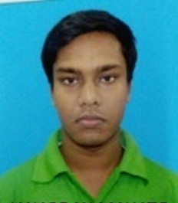
Name-JANARDAN MAHATO
Mobile no-7602370752
Whatsapp No.-7602370752
Email Id-janardanmahato315@gmail.com
DOB-29.07.1993
Gender-Male
Marital Status-Unmarried
Address-vill-Chhaitantala
P.O-Nalagola ,P.S-Bamangola
Dist-Malda, 733124

Qualification
Exam Name | Institute Name | Year of passing | Marks percentage
MP | W.B.B.S.E | 2010 | 60
HS(Arts) | W.B.C.H.S.E | 2012 | 74
B.A English(hons) | Kalyani university | 2016 | 42
M.A (English) | Rabindrabharati  university | 2018 | 55

Extra Qualification-1.One year Diploma in computer
2.D.EL.ED (2 years)

