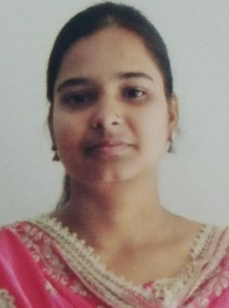
Curriculum Vitae
Chandrama Sarkar
Add:- Khaihatta,Mangalbari
Dist.:- Malda, Pin:- 732142
State:- West Bengal
Contact No:-8637377097
Email:- sarkarchandrama747@gmail.com
CAREER OBJECTIVE:-

Aiming to achieve a challenging and professional position from where I can make a significant contribution to the organization in the form of my dedication by using all my skills.
EDUCATIONAL QUALIFICATIONS:-
Sl No. | Name of Examinations | Board/  University | Year of Passing | Percentage of marks
1 | Secondary | W.B.B.S.E | 2014 | 56.42%
2 | Higher Secondary | W.B.C.H.S.E | 2016 | 70.20%
3 | B.Sc in Mathematics | University of Gour Banga | 2019 | 51.87%
4 | M.Sc in Mathematics | University of Gour Banga | 2021 | 89%
Extra Qualification:-
- 1 year Diploma in Computer
- Completed B.ED. in 2023
Personal details:-
- Father’s Name : Subodh Sarkar
- Date of Birth : 01/06/1998
- Nationality : Indian
- Gender : Female
- Marital Status : Unmarried
- Languages Known : Bengali, English, Hindi
Declaration:
I hereby declare that the information stated above is true to the best of my knowledge and believe.

