BIO DATA
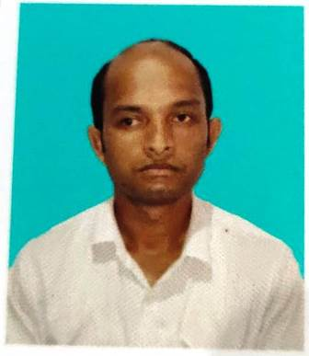

Name : BABU MONDAL
Father’s Name : MOIJUDDIN AHMED
Mobile : 7384311835
Gender : MALE
Date of Birth : 17/02/1993
Marital Status : MARRIED
Religion : ISLAM
Nationality : INDIAN
Education Qualification :-
NAME OF THE EXAMINATION | BOARD/UNIVERSITY | YEAR OF PASSING | TOTAL MARKS | MARK OBTAIN | PERCENTAGE
MP | WBBSE | 2009 | 800 | 412 | 51.5%
H.S | WBCHSE | 2011 | 500 | 268 | 53.6%
B.A(Bengali Hons) | WBNSOU | 2020 | 800 | 475 | 59.38
BLIS | WBNSOU | 2021 | 800 | 669 | 83.38%

Address :
VILL+P.O-BARALA
P.S-RAGHUNATHGANJ
DIST-MURSHIDABAD
PIN-742235

Declaration
I hereby declare that all the information provided here is true to the best of my knowledge.

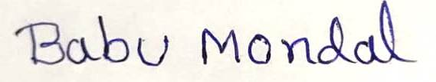
Place:-Barala
Date:-25/09/2023 Signature.

