CURRICULAM VITAE
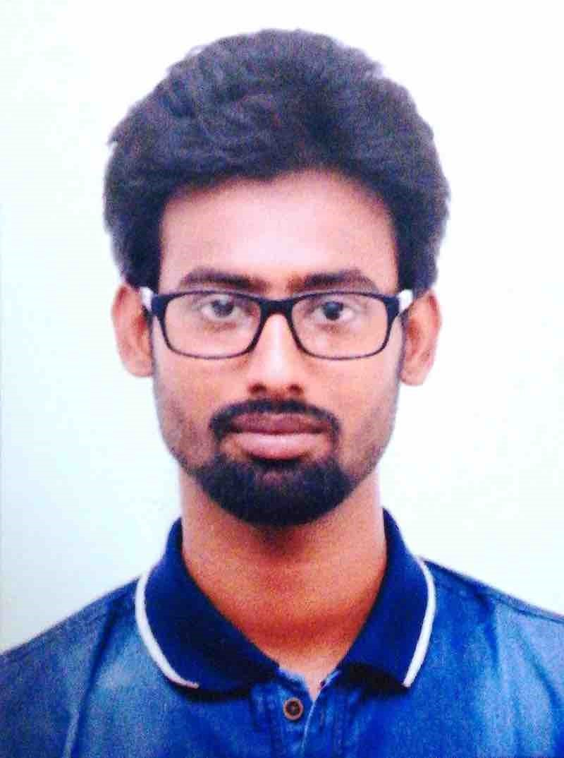
NAME:SOURAV CHAKRABARTY
(M) +91-7980167386;
E-mailid:tutulsourav8@gmail.com

CAREER OBJECTIVES: To obtain a respected and challenging position through which I can contribute to the growth of your reputed Institute.

ACADEMIC QUALIFICATION:
NAME OF THE  DEGREE | NAME OF THE  BOARD/UNIVERSITY | SCHOOL/COLLEGE NAME | YEAR  OF  PASSING | MARKS  OBTAINED
Madhyamik | W.B.B.S.E | Suri Sree Sree Ramkrishna Vidyapith | 2010 | 686/800(85.75%)
Higher  Secondary(10+2) | W.B.C.H.S.E | Suri Sree Sree Ramkrishna Vidyapith | 2012 | 400/500(80%)
Hons.in Bengali | Visva-Bharati | Bhasha Bhavana | 2015 | 69.10%
Masters in Bengali | L Visva-Bharati | Bhasha Bhavana | 2017 | 70.90%
B.Ed.  Ph.D | Visva-Bharati  University of North Bengal | Vinaya Bhavana  Bengali Department | 2019  2021 | 78.80%  Pursuing

- Qualified SET (2020) in Bengali

WORK EXPERIENCE:

Reporting for Ananda Bazar Patrika as a freelancer at Shantiniketan & Suri, Birbhum

TECHNICAL KNOWLEDGE:

Basic Knowledge in Computer

EXTRA CURRICULAR ACTIVITIES:

Drama, Sports and Recitation

HOBBIES:
Watching Movies, Plays and Sports, Listening to music, Writing, Reading
LANGUAGES KNOWN:
English(R,W,S),Bengali(R,W&S)and Hindi(R,W&S).
PERSONALDETAILS:

FATHER’S NAME: Mr. Kajal Kumar Chakrabarty
MOTHER’S NAME: Mrs. Namita Chakrabarty
PERMANENT ADDRESS: C/O- Kajal Kumar Chakrabarty, 'Devangan', SamanwayPally, Suri, Birbhum
P.O: Suri
P.S: Suri
District: Birbhum
State: WestBengal, Pin-731101
PRESENT ADDRESS: C/O- P C Chanda, Pravat Villa, Vidyapith Road
South Babupara Ext., Laketown, Siliguri, Pin- 734004
Date of Birth:09/04/1995
Nationality: Indian.
Gender: Male
Date:
Declaration: I here by confirm that all the information provided here is correct to the best of my knowledge and belief.
Signature
