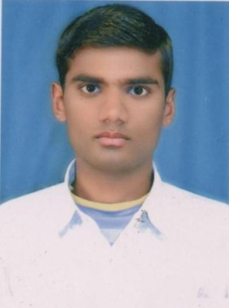
CURRICULUM – vitae

MD SAZZAD ANSARI
m
VILL-Kalchini T.E Masjid Line
Alipurduar-735217
West Bengal India
Email-sazzada376@gmail.com
Contact:-91+7797849325/91+9733263972

_________________________________________________________________________________

Objective:
To invest time and energy to meet in the need of the organization to achieve a meaningful position, which enables to be a better team member and manage things in a more effective and productive manner for the growth and prosperity of the organization.

EDUCATION QUALIFICATION

Sl No | Name of Class | Name of Board | Passing Year | Percentage
01 | MA | NBU | 2016 | 54.25%
02 | BA (Hons) | NBU | 2014 | 49%
03 | H.S | WBCHSE | 2011 | 53%
04 | M.P | WBBSE | 2008 | 55%
05 | B.ED | WBUTTEPA | 2018 | 69%

EXTRA QUALIFICATION

- Tally Course from Rashtriya Computer Literacy Drive (RCLD Kalchini)

- B.ED Degree from The West Bengal University of Teachers’ Training Education Planning & Administration (WBUTTEPA University from Kolkata)

COMPUTER SKILLS

- Data Entry, Typing with speed 40wpm.
- Data Analysis: Microsoft Office.
- Internet, E-mail etc.

JOB EXPERIENCE: OMEGA English Academy and Montessori, KALCHINI
: Class- 9 and 10
: Subject- Hindi
: Duration- 5th Jan 2022 to 29th Dec 2022

PERSONAL DETAILS

- Name ! MD SAZZAD ANSARI
- Date of Birth ! 19th July 1992
- Marital Status ! Single
- Nationality ! Indian
- Religion ! Islam
- Sex ! Male
- Language Known ! English, Hindi, Bengali, Urdu, Sadri,Nepali.
- Physical Status ! Height: 5’5’’ Weight : 50kg

DECLARATION

I hope that your consideration will be beneficial for my bright future. If you will give a chance to express my ability. I assure you that I would be honorable and thankful for you. I hereby declare that the above particulars are true & complete to the best of my knowledge.

Date: 02-09-2023 Yours’ faithfully,
Place: Kalchini Md Sazzad Ansari

