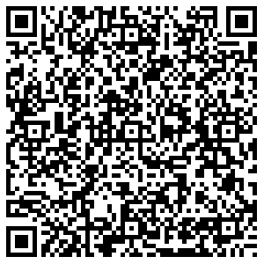
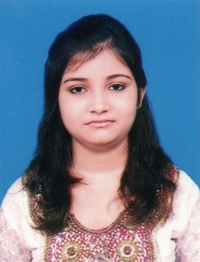
taniyachatterjee123@gmail.com

+91 8240274996
TANIYA CHATTERJEE
Social Science Teacher (ICSE, CBSE, WBBSE)
ABOUT ME
WORK EXPERIENCE
6.5 Years
As a human being, I want contentment through my perfection in my activities & clarify in a successful life, the foundation of which lies within the code of morality.

AGE
27


Education

M.A. in Psychology Appearing
Asutosh College Session: 2022-24
IGNOU
Kolkata, West Bengal
B.Ed. August 2021
Santipur B.Ed. College Marks : 89.70%
W.B.U.T.T.E.P.A. Division/Class : 1st
Santipur, Nadia, West Bengal
D.El.Ed July 2019
Rishi Arabinda College of Education Marks : 84.00%
N.I.O.S. Division/Class : 1st
Krishnagar, Nadia, West Bengal
M.A. in Education July 2018
Main Campus Marks : 64.87%
University of Kalyani Division/Class : 1st
Kalyani, Nadia, West Bengal
B.A. in Education(Hons.) July 2016
Kalyani Mahavidyalaya Marks : 61.00%
University of Kalyani Division/Class : 1st
Kalyani, Nadia, West Bengal
10+2 (Higher Secondary) May 2013
Sarat Kumari Girls High School Marks : 70.40%
W.B.C.H.S.E. Division/Class : 1st
Santipur, Nadia, West Bengal
10th (Madhyamik) May 2011
Sarat Kumari Girls High School Marks : 76.84%
W.B.B.S.E. Division/Class : 1st
Santipur, Nadia, West Bengal

Career Highlights

To be a dynamic professional in my chosen field and work to the full of my abilities and to build a symbolic relationship with my organization. Looking forward to an organization having professional outlook, believing in teamwork and goal orientation and having career plans for its employees.


Skills

- Classroom Management
- Fluently Spoken English
- Time manager
- Quick learner
- Team worker
- Record Keeping

- Lesson Plan Creation
- Punctuality
- Conflict Resolution


Work Experience

- December 2019 – Till Date
PG Teacher
St. Mary’s Group of Institutions
Ranaghat, Nadia, West Bengal

- Class-XII Education Teacher
- Class-XI Education Teacher
- Class Teacher- Class-X
- Social Science Teacher- Class-IX/VIII/VI

- October 2018 – November 2019
Assistant Teacher
Santipur Public School
Santipur, Nadia, West Bengal

- Class Teacher- Class-X
- Social Science Teacher- Class-IX/VIII/VII/VI

- April 2016 – September 2018
Assistant Teacher
Santipur Kidzee
Santipur, Nadia, West Bengal

- Class Teacher- Sr. Kg.
- Class Teacher- Jr. Kg.
- Administrator


Computer Proficiency

- Basic & Fundamental Knowledge
- Operating System (Windows XP/Vista/7/8/8.1/10/11)
- Microsoft Word 2003/2007/2010/2013/2019
- Microsoft Excel 2003/2007/2010/2013/2019
- Microsoft Power Point 2003/2007/2010/2013/2019


Languages

- English
- Bengali
- Hindi


Personal Interests

- Reading Books
- Internet Surfing
- Listening Music
- Watch Movie
- Travelling
- Photography


Personal Details

Father’s Name: Late Samir Chatterjee Marital Status: Married
Birthday: March 27, 1995 Nationality: Indian
Gender: Female Religion: Hinduism
Category: General Current Address : 21, Puin Para Lane
P.O. & P.S. – Santipur,
Dist. – Nadia,
Pin – 741404

Declaration
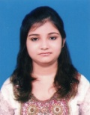
I, Taniya Chatterjee, hereby declare that the information contained herein is true and correct to the best of my knowledge and belief.
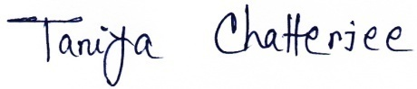

____________________________
Taniya Chatterjee Santipur, Nadia
October 11, 2022

