CURRICULUM VITAE
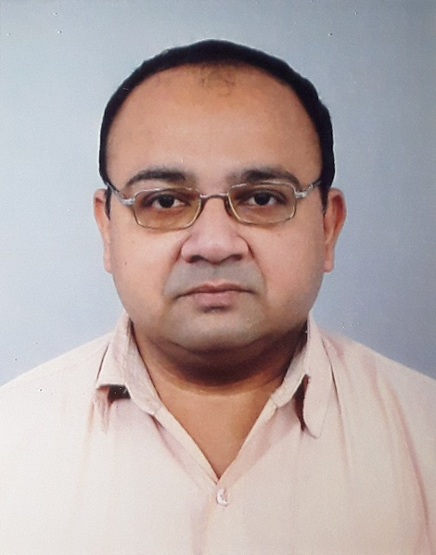

Personal Details

Name : Avik Mukherjee

Address : P-15, Gariahat Road (South),
Manjusa Flat 3NE,
Calcutta – 700 068.

Contact Number : 9433806375, 9231546480, 033 24237710

E-mail : avik.mukh.2014@gmail.com

Date of Birth : 08.10.1980.

Qualification : MCA

Certification/ : SCJP 1.5

Experience : 16 years in IT Education & Training

Aditya Birla Public School (BBSR) – 5th April 2022 – till date
Teacher of Computer Science

NSHM College of Management and Technology, Durgapur - May 2018 to 31.03.2022.
Current Designation : Asst. Professor,
Dept. of BCA, Data Sc & Analytics

Aditya Birla Public School (BBSR) - Sept 2017 - May 2018
Teacher of Computer Science

Bengal Institute of Technology (Aug 2008 - Sept 2017)
Last Designation : Asst. Professor, Dept. Of MCA

Kendriya Vidyalaya (Cossipore) – as PGT(Computer Sc.) – PRT

CMC Ltd – (Dec 2005 – Aug 2008)
Last Designation: IT Engineer (Education & Training)

Courses / :
workshops attended
- Python Basics – Online Course authorised by University of Michigan, offered through Coursera
- Faculty Development Program on Python, E & ICT Academy, IIT Kanpur

- Faculty Development Program on Data Science, E & ICT Academy, IIT Kanpur -

- 5-day online FDP on the theme “Inculcating Universal Human Values in Technical Education” organized by All India Council for Technical Education(AICTE)

- ‘High Impact Teaching Skills’ by Dale Carnegie Training

- ‘Improvement of Teaching Methodology’ conducted by National Institute of Technical Teachers’ Training & Research, Kolkata

- ‘Leading Self’, ‘Building Presence’, ‘Speaking Effectively’ and ‘Listening Activities’ – Courses through Harappa Education

- ‘Introduction to Big Data’ – Online Course authorised by University of California San Diego, offered through Coursera

- Wipro ‘Mission 10X’

- Infosys FEP at Bhubaneswar

Professional Experience Details

Aditya Birla Public School (BBSR) from 5th April 2022 – till date
Teacher of Computer Science, Class Teacher for Class VIII

NSHM College of Management and Technology, Durgapur from May 2018 till date
Current Designation: Assistant Professor, Dept. of BCA

Aditya Birla Public School from September 2017 to May 2018
As a Senior Teacher and Incharge of the Computer Sc Dept.

Bengal Institute of Technology from August 2008 to September 2017
Current Designation: Assistant Professor, Dept. of MCA

Job Profile:
As Project Mentor/Guide/Trainer for MCA/BCA/B.Tech students of Techno India Group
As Faculty in The Dept. of MCA
As Trainer in Faculty Training Programs of Techno India Group

Kendriya Vidyalaya, Cossipore - As PGT(Computer Sc.) - PRT

CMC Ltd (Education & Training SBU) from December 2005 – August 2008.
Last Designation: IT Engineer (Education & Training SBU)

Job Profile:

As Batch Mentor in TCS ILP.

As Recruitment Panel Member for TATA Steel (Jamshedpur), and CMC Ltd ATC Faculties.

As Training/Placement Coordinator for CMC Ltd (E & T SBU) Kolkata

As Corporate Trainer for HLL, DGQA (Naval), ITC Ltd., Zoological Survey of India, Chittaranjan Locomotive Works Ltd., Tech Mahindra, TCS ILP, Balarampur Chini Mills, NALCO

As Faculty for M.Sc., B.Sc(Hons.) & MCA courses under University of Burdwan, NSOU and Jadavpur University.

As Course Coordinator for:
- Degree college training courses run by CMC Ltd.,
- B.Sc Computer Sc. (Hons.) under affiliation of University of Burdwan,
- M.Tech (IT) & PGDMWT course run under affiliation of Jadavpur University
- Corporate Training at NALCO.

Examiner for
- Jadavpur University (PGDMWT),
- NSOU (MCA & BCA),
- University of Burdwan (M.Sc-CT),
- West Bengal University of Technology (MCA)

Guest Lecturer in ‘Indian Institute of Professionals’ for B.Sc. (IT) , M.Sc(IT), BCA & MCA. Under affiliation of University of Madras & Vinayaka Mission research Foundations.(Deemed University) from August 2005 – December 2005.

Educational Qualification:

MCA (Post Graduation) :

Name of Examination : Master of Computer Applications.
Year of Passing : 2005.
College from where appeared : JIS College of Engineering, Kalyani
University : West Bengal University of Technology
DGPA : 8.39 ( in a 10-point scale)
(DGPA Degree Grade Point Average)

Summer Training : Hardware & Networking under ‘Core Network Solutions’.

Minor Project : ‘Online Banking’ using J2EE & DB2 under IBM.

Major Project : ‘Mail Server’ using STRUTS.

B.Sc. (Graduation) :

Name of Examination : B.Sc. (3Yr. Hons.)(Physics)
Year of Passing : 2002
College from where appeared : Surendranath College
University : University of Calcutta
Subjects : Physics (Hons.), Mathematics, Computer Science, Compulsory English & Bengali

ISCE (XII Standard) :

Name of Examination : Indian School Certificate Examination
Year of Passing : 1999
School from where appeared : Calcutta Boys’ School
Council/Board : Council for the ISC Examinations, New Delhi
Subjects : English, Bengali, Physics, Chemistry, Mathematics, Computer Sc.,

ICSE (X Standard) :

Name of Examination : Indian Certificate of Secondary Education Examination.
Year of passing : 1997
School from where appeared : Calcutta Boys’ School
Council/Board : Council for the ISC Examinations, New Delhi
Subjects : English, Bengali, History Civics & Geography, Science, Mathematics, Computer Sc.

Software Skills:

Operating Systems : DOS, Windows, Linux, UNIX

Software / General Applications : Python, C, C++, JAVA, J2EE, COBOL & FORTRAN (Basics), BASIC, HTML, Web page design, Microsoft Project,.

Databases : Oracle, DB2, Ms Access

Networking : Linux System Administration,
Worked as a Trainee (Network Engineer) under ‘Core Network Solutions’.

Avik Mukherjee

