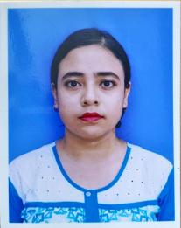
CURRICULUM VITAE

Name- BIPASHA MUNSHI
Phone no- 7431030608
Email id- bipashamunshi1997@gmail.com

ACADEMIC QUALIFICATION
Course | College | Year | University/board | Percentage
Secondary | Barlow Girls’ High School | 2014 | WBBSE | 71.28
Higher Secondary | Barlow Girls’ High School | 2016 | WBCHSE | 83.60
Bachelor of arts (Bengali Honours) | Malda College | 2016-2019 | UGB | 54.45
Master of arts (Bengali) | Malda college | 2019-2021 | UGB | 79.50
Bachelor of Education | Govt Teachers Training College,Malda | 2021-2023 | WBUPPTA | Pursuing

EXTRA CURRICULAR ACTIVITY
- Diploma In Information Technology Application- (MS Word,Excel,Power Point)
- SHILPA RATNA In Drawing
- SHILPA VISHRAD In Rabindra Sangeet

LANGUAGE PROFICIENCY
- Bengali (Reading,Writting,Speaking)
- English (Reading,Writting,Speaking)

PERSONAL INFORMATION
- Date of Birth - 20TH September,1997
- Father’s Name- Chandan Munshi
- Mother’s Name- Beauty Munshi
- Residential Address- Air View Complex, Opposite ITI College, Malda, WB

