Resume

SMITA KUMARI

Mobile No. : 8409219475
Email : smitaprakashranjan@gmail.com

CAREER OBJECTIVE
To obtain an entry-level [industry] position at a respected organization and utilize the educational
qualification I have obtained.

SCHOLASTICS
- B.Ed from M.u 2018 with 1st division
- Ma from n.o.u patna 2016 with 2nd division
- Qualified TET examination in 2012 with 1st division
- B.A. From M.u2007 with 2nd division
- Intermediate from, BSEB (Patna) in 2003 with. 1st division
- Matriculation from BSEB (Patna) passed in 2001 with 2nd division

WORK EXPERIENCE

  - 2 years as a teacher of st Joseph school patna as Prt
  - Presently working in A.s . Krishna Niketan as Prt
PERSONAL TRAITS
  - Strong learning ability, accepting new challenges.
  - Easily adjusts in new environment, friendly behavior.
  - Believe in teamwork and cooperation to achieve fruitful results.

KEY STRENGTHS

- Determination towards work
- Positive attitude towards life

Personal Details:

Father’s Name : RAJ KISHORE LALL
Mother’s Name : RITA LAL
D.O.B : 20/03/1986
Gender : Female
Nationality : Indian
Marital Status : Married
Language : Hindi & English
Correspondence Add : W/O Prakash Ranjan
C/o Ashok Singh, mokama house, opposite f hanuman mandir, bazar samiti road , Patna- 800016

Declaration:

I hereby declare that all the information given above is sure and correct to the best of my knowledge and brief

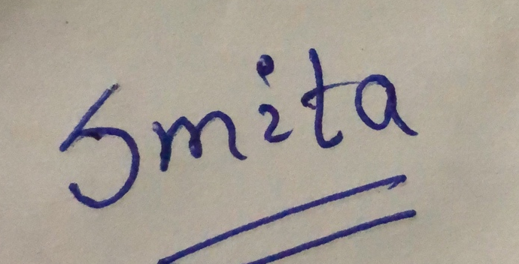
Date :
Place : Patna Signature

