BIO-DATA
Post Applied for.........................................................................

NAME: PALASH MANDAL 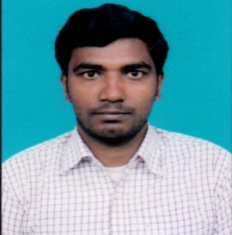
FATHER`S NAME: ABHIRAM MANDAL
MOTHER`S NAME: ANITA MANDAL
DATE OF BIRTH: 10-11-1991 GENDER: MALE
CASTE: SC RELIGION: HINDUISM NATIONALITY: INDIAN
ADDRESS:
VILL + P.O: SUKDEV PUR
P.S: BAISHNABNAGAR DIST: MALDA PIN: 732201
STATE: WEST BENGAL MOB: 9775890751
E-MAIL: mandalpalash1991@gmail.com
 | EXAM PASSED | BOARD/  UNIVERSITY |  | YEAR OF  PASSING | TOTAL MARKS | SECURED  MARKS | %
1. | MADHYAMIK | W.B.B.S.E. |  | 2008 | 800 | 592 | 74%
2. | H.S | W.B.C.H.S.E. |  | 2010 | 500 | 375 | 75%
3. | B.A. ENG (HONS) | UNIVERSITY OF  GOUR BANGA |  | 2013 | 800 | 413 | 51.62  %
4. | M.A IN ENGLISH | UNIVERSITY OF  GOUR BANGA |  | 2015 | 1600 | 906 | 56.62  %
6. | B.ED | UNIVERSITY OF  GOUR BANGA |  | 2017 | 2000 | 1538 | 76.90  %
7 | CTET | C.B.S.E | 2019 |  |  | 86

SIGNATURE

