RESUME
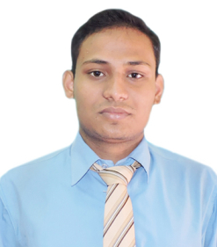
Name : Swastyaneek Prajna Prabak
Address : Durgapur,Paschim Bardhaman, WB
Mobile :8538026913
Email :bapidgp95@gmail.com

OBJECTIVE:
My objective is to become associated with an organization where I can utilize my skills and gain further experience while enhancing the organization’s productivity and reputation.

EDUCATIONAL QUALIFICATION:
Examination | Board/University | Year of passing | Percentage
BLIS | IGNOU | 2021 | 63%
D. El. Ed. | WBBPE | 2022 | 85%
B.Ed. | BU | 2019 | 60%
B.C.A | M.A.K.A.U.T | 2017 | 74%
H.S | W.B.C.H.S.E | 2014 | 55%
Madhyamik | W.B.B.S.E | 2012 | 81%

INDUSTRIAL TRAINING: (MINOR PROJECT)
- Organization : Flexonlabs (Durgapur)
- Project Undertaken : “eCARE”
- Language : PHP with mysql

MAJOR PROJECT:
- Project Undertaken : ‘Online Volvo Bus Ticket Booking’
- Language : PHP with mysql

STRENGTHS: Hard Working, Willingness to learn, Adaptability, Leadership quality.

INTERESTS: Listening songs and watching TV, Swimming , Travelling , Computer.

COMPUTER AND LANGUAGE SKILLS: Microsoft Office ,C Language ,Object Oriented Programming C++, DBMS, HTML, PHP, Data Structure.

PERSONAL DETAILS:
Date Of Birth : 21st Oct 1995
Permanent Address : Durgapur, Paschim Bardhaman , WB
Gender :Male
Nationality :Indian
Languages Known : Bengali, Hindi and English
Blood Group :B⁺
Marital Status :Single

DECLARATION:
I do hereby declare that the above statements are true and correct to the best of
my knowledge and belief.
DATE : 25/9/2023
