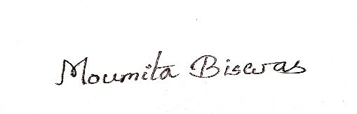
MOUMITA BISWAS  MOUMITA.BISWAS0231@GMAIL.COM  8145599529 / 8013160250 | 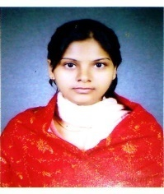
  Objective
  To secure a challenging position that utilizes my years of experience, while allowing me the opportunity to grow professionally
  Skills
  Diploma in Computer Application
  Certificate of Participation : National Level Seminar
  Topic- Bibhuti Bhushan Bandyopadhay, Pakuahat Degree College, Malda
  ATTRIBUTES
  HARDWORKING
  CREATIVITY
  POSITIVE
  Research Experience
  2017-2023 : Ph.D Researcher
  Tilka Majhi Bhagalpur University
  Bhagalpur, Bihar
  Education
  2011- 2013 : Mastersin Arts (Bengali Hon’s) 64.50%
  Womens College, Malda
  2010- 2011 : Bachelor of Education 59.70%
  Satish B.ed College, Malda
  2006- 2009 : Bachelor in Arts (Bengali Hon’s) 52.38%
  Womens College, Malda
  2006 : Higher Secondary (WBCHSE) 57.20 %
  Jalalia Girls High School, Malda
  2004: Madhymik (WBBSE) 50%
  Jalalia Girls High School, Malda
  PERSONAL INFO
  W/O :Md. Azaharuddin
  Add:Mahesmati,
  P.S- English Bazar, P.O- Malda , Pin- 732101
  D.O.B: 03.04.1988
  Religion: Muslim
  Maritial Status: Married
  Language: Bengali, English, Hindi
SIGNATURE

