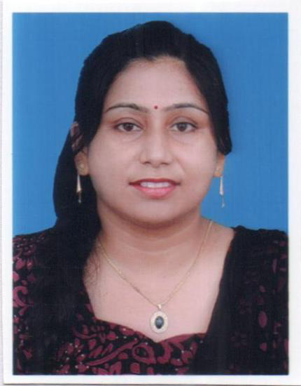
RESUME
Name – Munmun Banerjee
Father’s name – Shri Bidyut Kumar Banerjee
Mother’s name – Smt. Minakshi Banerjee
Gender- Female
Address- C/O Bidyut Kumar Banerjee
Kalyani Enclave
Flat No. – 201, North Loco Tank
Hirapur, Dhanbad- 826001
Jharkhand
Mobile No.- 7903196841, 8877533022
Email – munmunbanerjee666@gmail.com

Educational Qualification
Name of the Examination | Name of School/College | Board/University | Subject | Year of Passing | Percentage | Division
A.I.S.S.E | Dhanbad Public School | C.B.S.E | English, Hindi, Maths, Science, Social Science | 1999 | 62 | 1st
I.Sc | S.S.L.N.T College | J.I.E.C.R | Physics, Chemistry, Biology, English, Hindi | 2002 | 65 | 1st
B.Sc | S.S.L.N.T College | Vinoba Bhave University | Chemistry (Honours), Botany and Zoology(Subsidiary) | 2008 | 71 | 1st
M.Sc |  | Vinayaka Mission University | Chemistry | 2011 | 68 | 1st
B.Ed | Goutham College of Education | Bangalore University | Chemistry and Biology | 2009 | 77 | 1st

Work Experience
Name of the School | Classes taught | Number of years | Subjects taught
I.S.L I.S.M Annexe, Dhanbad (C.B.S.E) | VIII,IX,X as TGT | 2 | Chemistry,Biology
Dhanbad Public School, Dhanbad | VI to IX as TGT | 8 | Maths, Chemistry and Biology

Extra Knowledge – Passed ‘TALLY’ trade from JSS Dhanbad with ‘A’grade
Extra Information- 1. College topper in I.Sc
2. 7th Rank holder in B.Sc in Vinoba Bhave University, Hazaribagh
Last Salary Drawn- Gross Rs 40,000
Expected Salary Rs 45,000
Languages Known- Bengali, English, Hindi

Date: Signature:
Place:

