BUSHRA KHATOON 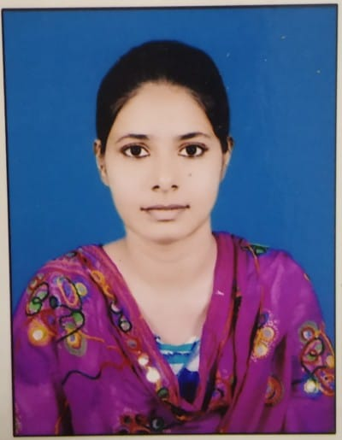
Mobile: +91-6299103118
E-Mail: khatoonbushra84@gmail.com

CAREER OBJECTIVE
- I am Masters in English Looking for teaching position.
- I would like to utilize my skills and experience as well as my passion for teaching to train and educate young minds.
PROFESSIONAL EXPERIENCE
- Home Tutor
BRIEF OVERVIEW
- Ability to multi-task, work under tight deadlines and also work with minimal supervision.
- Efficient analytical & planning skills with abilities in working in teams for achieving organizational goals.
ACADEMIA

Qualification | University/ College/ Board | Stream | Batch | %
B.Ed | Shine Abdur Razzaque Ansari Institute of Health Education & Research Center | English,  Economic | 2020-22 | 82.69
Post-Graduation | Marwari College Ranchi  (Ranchi University) | English | 2018-20 | 64.56
Graduation | Marwari College Ranchi  (Ranchi University) | English | 2015-18 | 64.19
12th | St. Xavier’s College Ranchi  (JAC Board) | Arts | 2013-15 | 62
10th | Carmel School Ranchi  (ICSE Board) | Physics, Chem, Maths, Science, Social Science, Hindi, English | 2013 | 65.6

COMPUTER PROFICIENCY
- MS Office 2000-2010
- Internet Application
- Basic Knowledge of HTML.

HOBBIES
- Reading
- Cooking
STRENGNTH
- Self Confidence
- Positive Thinking

PERSONAL DETAILS

Father’s Name : Taufique Quraishi
Date of Birth : 17th May 1996
Languages Known : Hindi, English, Urdu
Marital Status : Unmarried
Address : Kantatoli Purulia Road
Near Sharma Building
Ranchi 834001

DECLARATION

I consider myself familiar with professional aspects. I am also confident of my ability to work in a team.
I hereby declare that the information furnished above is true to the best of my knowledge.

Signature:
Bushra Khatoon

