RESUME

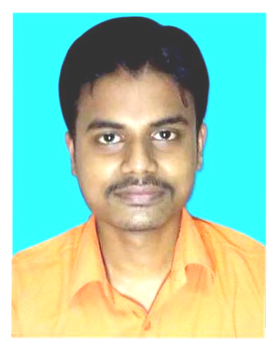

TIRTHO SAGAR MAZUMDAR
tirthomazumdar88@gmail.com
Mobile: 8906165247

CAREER OBJECTIVE

To have a career that enables me to ignite the inherent prodigy of pupils by teaching them in an ecstatic and exuberant way which will make them impassionate towards their studies.
ACADEMIC QUALIFICATIONS

- D.EL.ED – Passed from Holy child B.ed college, Malda ( WBBPE ) in 2021.

- P.G – M.A IN ENGLISH.

‘2013’ – Passed from Karnataka State Open University (Distance).

- Graduation – B.A IN ENGLISH (HONS).

’2009’ – Passed from North Bengal University.

- 10th +2 --
Passed in ’2006’ – In Arts stream from L.M.S.M High school, Malda.
- 10th--
Passed in ’2004’ – from L.M.S.M High school, Malda.

Details of Academic Qualification:

EXAM | BOARD/  UNIVERSITY | FULL MARKS | MARKS OBTAINED | PERCENTAGE | DIVISION | PASSING YEAR
MADHYAMIK | W.B.B.S.E | 800 | 518 | 64.75% | 1ST | 2004
HIGHER SECONDARY | W.B.C.H.S.E | 1000 | 690 | 69.00% | 1ST | 2006
B.A (HONS) | N.B.U | 800 | 368 | 46.00% | 2ND | 2009
M.A | K.S.O.U | 1000 | 502 | 50.20% | 2ND | 2013
D.EL.ED | WBBPE | 1400 | 1173 | 83.78% | 1st | 2021
COMPUTER PROFICIENCY

Office Utilities : MS Word, MS Excel, Internet etc.
LANGUAGE KNOWN

- Bengali
- English
- Hindi
PERSONAL DETAILS

Father’s Name : Mr. Chandan Majumdar.
Date of Birth : 14th August 1988.
Permanent Address : Vill- Char Kadirpur, (Near Radha Krishna Temple),
P.O – Sahapur, P.S – Old Malda,
Dist-Malda.
Pin-732142.
State- West Bengal.

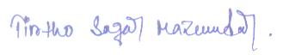
…...........................................................

SIGNATURE

