RESUME

JAYANTI DAS
C/O- ANUP KUMAR DAS
Mob No: +918918312426
Email ID: dasjayanti1607@gmail.com
Address:
BALIA NAWABGANJ
MALDA, WEST BENGAL
PIN-732128

CAREER OBJECTIVE
- To persue a challenging career and be a part of progressive organisation that gives a scope to enhance my knowledge utilising my skills towards the growth of the organisation.
QUALIFICATION | SUBJECT | BOARD/UNIVERSITY | YEAR | %/CGPA
10TH | ALL | W.B.B.S.E | 2011 | 67
10+2 | ARTS | W.B.C.H.S.E | 2013 | 73.40
GRADUATION | SANSKRIT | MALDA COLLEGE | 2016 | 65.12
POST GRADUATION | SANSKRIT | UNIVERSITY OF GOUR BANGA | 2018 | 80.4
BACHELOR OF EDUCATION  (B.ED) | SANSKRIT | VIVEKANANDA  TEACHERS TRAINING COLLEGE | 2020 | 82.35

ACADEMIC QUALIFICATION

TECNICAL SKILL/ COMPUTER ABILITY

- M.S Office Word, Excel, MS Power Point,
- Operating systems Known: Windows X p, Windows 7,8,10

MY EXPERTISE
- Comprehensive problem solving capabilities, good verbal and written communication skills.
- Highly flexible and adaptable performer and can work effectively in a group as well as individually.
- Quick learner who readily accepts a challenge and responds to problem situations promptly.
- Mentoring more than 200+ students since 2019.

MY JOB EXPERINCE
INSTITUTE NAME | DURATION
DIGITAL SIKSAH COACHING CENTER  Mangalbari,Malda,732142 | MARCH 01,2019  TO  MARCH 30,2020

Declaration:
I hereby declare that all the information mentioned above is true to the best of my knowledge. I will make it my earnest endeavor to discharge completely and carefully the duties you may be pleased to entrust with me.

Date: 17/04/2021 Yours Obediently,
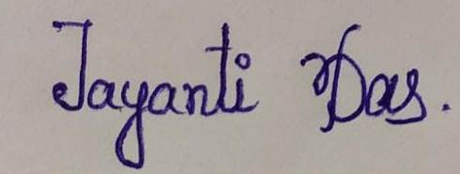
Place: MALDA

