BIO DATA

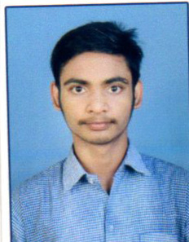
Name : Somen Maji
Father’s Name : Bablu Maji
Date of Birth : 15/01/2002
Gender : Male
Marrital Status : Unmarried
Languages Known : Bengali, English, Hindi
Permanent Address : Vill – Ghusra, p.o- Ardhagram, p.s- Mejia, Dist – Bankura, PIN- 722143
Email Id : Somenmaji.asn@gmail.com
Mobile No : 8250018459
Category (SC/ST/BC/OBC/General) : Sc
Religion : Hindu
Educational Qualification :

Name of the Exam | Year of Pass | Board/University Name | Specialization | Percentage
Madhyamik | 2018 | WBBSE | - | 60..28%
Higher Secondary | 2020 | WBCHSE | Arts | 86 2%
Graduation | 2023 | BANKURA UNIVERSITY | History Honours | 79.38%

Declaration: I hereby declare that all the above information is true to the best of my knowledge.


Date :
Place : Ghusra Signature

