KUMARI DIKSHA 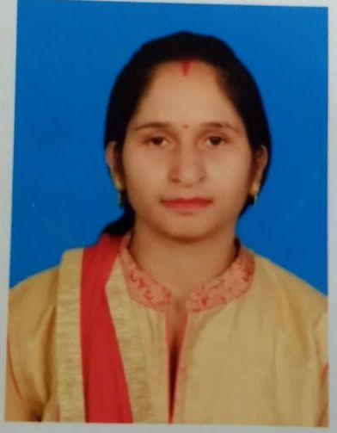
Address: Shivpuri Near B B M High School, Purnea
D O B: 15-02-1989
Email: kumaridiksha77@gmail.com
OBJECTIVE
Develop and promote creativity and high-order thinking skills that increase the performance of the students.

EXPERIENCE- 1.5 YEAR
- School Name: APWS Purnea

- Teaching all subjects Nursery to 6th class.
- Organize functions and cultural activities.

- Training in Government School Deoghar 2019

- Teaching commerce and economics subject to 9th class.

EDUCATION
- 10TH:- Modern Public School Deoghar, Jharkhand
- Year of Passing:- 2005
- Percentage:- 52%

- HSC:- R D Bajla Mahila College Deoghar, Jharkhand
- Year Of Passing:- 2007
- Percentage:- 54%
- B.com(Hons.):- A S College Deoghar, Jharkhand
- Year Of Passing:- 2011
- Percentage:- 63%
- B-ed:- Jasidih B-ed College Deoghar,Jharkhand
- Year Of Passing:- 2020
- Percentage:- 82% With Distinction.
- M.com:-Ignou
Pursuing 2021
- Computer(ADCA):- Tata Infotech Deoghar,Jharkhand
- Ms-word, Ms- excel, Power point, Ms-access
- Ctet 2021 qualified paper 1
LANGUAGE

- English
- Hindi

ACHIEVEMENTS

- Painting Certificate

- Kathak Dance Certificate
HOBBIES

- Listning Music

- Playing Outdoor Game

I here by declare that the above mentioned details are true to the best of my knowledge.

DATE:-

PLACE:- Purnia
KUMARI DIKSHA

