CURRICULUM VITAE

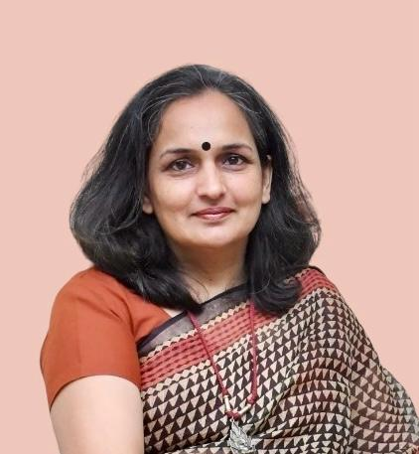
CONTACT INFORMATION:
Shiva Bishnoi
23C, CGO Residential Complex
Sector 38 A
Chandigarh 160036
Email: bishnoishiva@gmail.com
Mobile: 8826716444

OBJECTIVE:
Dedicated and experienced educator with over a decade of expertise, seeking a dynamic position as a Subject Matter Expert. With years of experience as Academic Coordinator and English teacher, I aim to apply my strong language skills to deliver high-quality academic content, including reports, essays, assignments etc. My expertise in language and communication, combined with a keen understanding of academic writing, will enable me to produce clear, well-researched, and impactful content tailored to academic standards and specific subject requirements. I am committed to consistently providing exceptional written material that meets the unique needs of each project, while adhering to deadlines and maintaining high professional standards.

SCHOLASTICS:
- University Grants Commission NET for Lectureship 2000
- Agricultural Scientists Rectt. Board NET for Lectureship 2004
- Rajasthan Agri. University, Bikaner; M.Sc. (F&N) 2000
- Rajasthan Agri. University, Bikaner; B.Sc. Home Sc. 1998
- I.A.S.E. University, Sardarshahar (Raj); M.A. (Ed) 2008
- Jammu University, Jammu; B.Ed. 2003
- British Council; Spoken English Upper Intermediate 2009
- IIM Bangalore; Women Startup Program 2022-2024
- India SME Forum; Orientation Program for Exports 2024

Contd/-

EXPERIENCE:
- Lead Mentor (Year 1 to 6), Activity Coordinator and SOF/ACER Coordinator at Mayoor School, Sri Ganganagar.
- Coordinator for Cambridge Assessment International Examination (CAIE) & ISA by British Council.
- TGT (English), Year 7 to 10 at Mayoor School, Sri Ganganagar.
- Lecturer of Home Sc. (F&N) at SGN PG Khalsa College, Sri Ganganagar. Subjects for teaching were Biochemistry, Food Science and Therapeutic Nutrition.
- Lecturer of School Management & Statistics at Himalayan B.Ed. College, Rajouri (J&K).
- TGT (English) at Himalayan School, Rajouri (J&K) and Merry Angel’s Public School, Sri Ganganagar.

STRENGTHS:
- Good Communication Skills.
- Good Inter Personal Relationship.
- Open To Shoulder Responsibilities.
- Dedicated and Hard Working.

REFRENCES:
- Dr Roiana Khan, Head of School, Fort City School, Vizianagram (Andhra Pradesh), Mobile No. 9557911979
- Dr Aanieetaa Vaissnava, Principal, Vidya Jain Public School, Rohini, New Delhi, Mobile No. 9810075227

