BIO-DATA
NAME - ANJALI BHOWAL
FATHER’ NAME – ARJUN BHOWAL
MOTHER’S NAME – SARASWATI BHOWAL

PERSONAL DETAILS | ADDRESS
GENDER - FEMALE | SUKANTA PALLY, BIDHAN NAGAR
NATIONALITY- INDIAN | POST OFFICE – BIDHAN NAGAR
RELIGION - HINDU | DISTRICT -DARJILING
CATEGORY – OBC(B) | P.S. - PHANSIDEWA
MARITAL STATUS - UNMARRIED | PIN - 734426
DATE OF BIRTH – 20/07/1995 | PHONE NO-8944971623

EMAIL ID – anjalibhowal.anjali@gmail.com
HOBBY – PAINTING , CRAFTING ,READING
LANGUAGE KNOWN – BENGALI, ENGLISH, HINDI
PROFESSIONAL EFFICIENCY :-
- A passion about the teaching field with a great teaching aptitude.
- Thorough knowledge of the subject to be taught and its background.
- Effective classroom management.
EXAM PASSED | BOARD/ COLLEGE/ UNIVERSITY | YEAR OF PASSING | PERCENT-AGE | DIVISION
SECONDARY | BIDHANNAGAR SANTOSINI VIDYACHAKRA HIGH SCHOOL (WBBSE) | 2012 | 77.43% | FIRST
HIGHER SECONDARY | BIDHANNAGAR SANTOSINI VIDYACHAKRA HIGH SCHOOL (WBCHSE) | 2014 | 80.40% | FIRST
B.A (GEOGRAPHY HONOURS) | N.B.U | 2017 | 57.38% | SECOND
MASTERS IN GEOGRPHY | CHHATRAPATI SHAHU JI MAHARAJ UNIVERSITY, KANPUR | 2019 | 61% | FIRST
B. Ed | PHANSIDEWA  PRIMARY TEACHERS' TRAINING INSTITUTE (UNDER- WBUTTEPA) | 2021 | 89.55% | FIRST

- C-TET QUALIFIED FOR BOTH PAPER -1 AND PAPER-2
- EXTER CURRICULUM:JUNIOR DIPLOMA IN DRAWING (Recognised by Govt. , affiliated to Rabindra Bharati University)
SKILLS & KNOWLEDGE :
- HAVE BASIC COMPUTER KNOWLEDGE WITH DIPLOMA
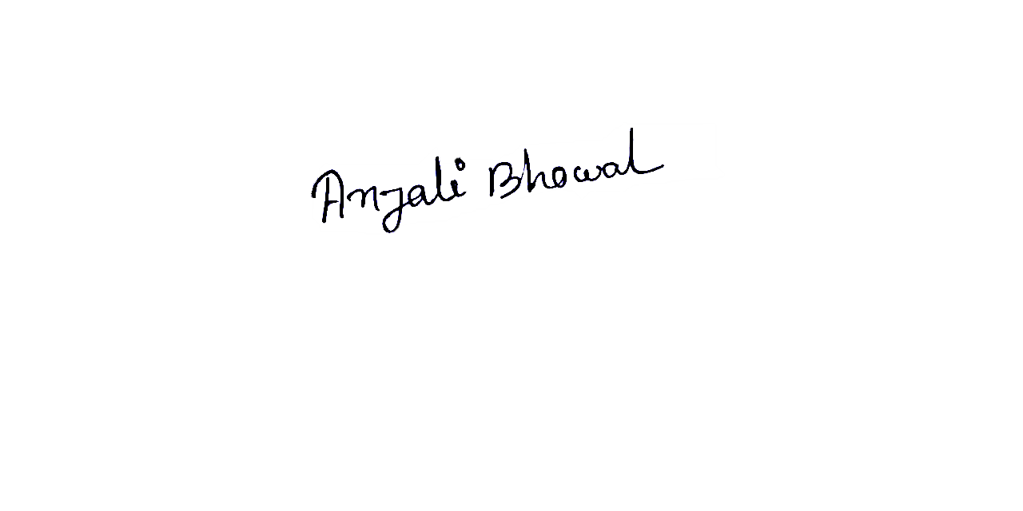
DECLARATION: - I hereby declare that all the details furnished are true to the best of my knowledge.
Date: Signature

