CURRICULUM VITAE

Name : ABIRA ZAMAN 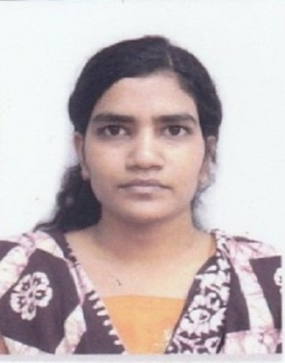
Address : 61/105 VIVEKANANDA PALLY, SOUTH, NEAR NUJRUL SMRITY PRIMARY SCHOOL, P.O+D.T-MALDA, P.S ENGLISH BAZAR, PIN-732101

Contact No. : 9547284602 (M)
6295114511 (M)
E-mail : zamanabira@gmail.com
Career Vision : To pursue a career in an organization that will provide me an opportunity to enhance my skills, intelligence and knowledge as a teacher.

Marital Status : Unmarried
Date of Birth : 15th November, 1999
Father’s Name : MD ASADUZZAMAN

Mother’s Name : SALEHA KHATUN

Religion : ISLAM

Academic Qualification

2020-2022: Passed Master Degree course in Life Sciences with 70.2 % marks (CGPA=7.75) from Presidency University, Kolkata.

Semester | SGPA
First | 7.00
Second | 7.40
Third | 8.00
Fourth | 8.60

2017-2020: Passed Bachelor Degree course in Life Sciences (Major/ Honours) with 67% marks
(CGPA= 7.56) from Presidency University, Kolkata.

Semester | SGPA(Major Subject) | SGPA(Extra Departmental Subjects)
First | 7.40 | 6.00
Second | 8.20 | 6.67
Third | 6.14 | 5.00
Fourth | 6.29 | 8.50
Fifth | 7.83 | -
Sixth | 8.50 | -
2017 : Passed from WBCHSE with 82.6 % of marks from Barlow Girls’ High School, Malda.
Subjects | Percentage Marks
English | 75
Biology | 88
Bengali | 86
Mathematics | 86
Physics | 70
Chemistry | 78

2015 : Passed from WBBSE with 89.42 % of marks from Barlow Girls’ High School, Malda.

Subjects | Percentage Marks
English | 90
Bengali | 83
History | 84
Geography | 85
Mathematics | 96
Life Science | 93
Physical Science | 95

Qualification : Currently studying in YUNUSH B.Ed COLLEGE (2022-2024).

Dissertation : Worked under Dr. Mausumi Sikdar (Nee Bhakta) (Department of Life Sciences) as a dissertation student.

Internship : Worked under Dr. Mausumi Sikdar (Nee Bhakta) (Department of Life Sciences), Presidency University as an intern.

Reports and Reviews :
- Field Report and Diet Survey in East Districts of Sikkim (B.Sc., 2020).
- The Role of Non-Ionizing Electromagnetic Radiation in Altering Neurophysiology
_A Review (M.Sc., 2022).
Presentations:
International Conference (Online) Poster Presentation at Presidency University on 25th and 26th August, 2022.

Extra-curricular activities:
- Teaching all subjects to students of Class-VI to Class X of West Bengal board as a tutor since 2017.
- Teaching Biology to students of Class XI to Class-XII of West Bengal, ICSE and CBSE board as a tutor since 2020.
- Completed Certificate Course from Indian Space Research Organisation on Overview of Geocomputation and Geo-web services, conducted during 31-10-2022 to 04-11-2022.
- Completed Computer Course named Smart Office from Zed InfoTech from15/12/2014 to 15/06/2015.
Achievements :
        - 3nd Rank in Paschim Banga Vigyan Mancha ( Barlow Girls’ High School) in 2012-13

Languages Known : English, Bengali, Hindi, Arabic and Sanskrit. Date: 28.06.2023

