CURRICULUM-VITAE

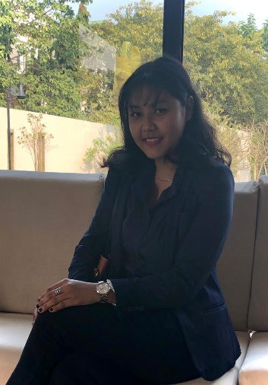
MANISHA PRADHAN

ADDRESS:
Lower Bagdogra
Village – Baunivita, Gossianpur
P.O. – Bagdogra
District- Darjeeling
Pin – 734014

CONTACT DETAILS:
Phone No: +91 7479031860/ 8389071010
E-mail: manisha77pradhan@gmail.com

CAREER OBJECTIVE:

- To fully devote myself to the job assigned and contribute in achieving the organization’s objective.
- To gain experience while with the best talents.
- To enhance my technical skills and self-confidence.

PERSONAL ATTRIBUTES

- A strong belief in hard work, to devote myself in the work.
- Positive attitude & good communication skills.
- Hardworking, Self-motivated and punctual.

EDUCATIONAL QUALIFICATION

DEGREE | UNIVERSITY / BOARD | INSTITUTION | YEAR OF PASSING | DIVISION
10TH STANDARD | C.B.S.E. | KENDRIYA VIDYALAYA BENGDUBI | 2009 | I
12TH STANDARD | C.B.S.E. | KENDRIYA VIDYLAYA BENGDUBI | 2011 | I
B.COM | N.B.U. | KALIPADA GHOSH TARAI MAHAVIDYALAYA | 2015 | II
B.ed | ACHARYA NAGARJUNA UNIVERSITY | ACHARYA NAGARJUNA UNIVERSITY | 2021 | 82%
D.ED IN SPECIAL EDUCATION | NORTH BENGAL HANDICAPPED REHABILITATION SOCIETY | REHABILITATION COUNCIL OF INDIA | 2024 | Completed

- ﻿﻿Qualified CTET- 2022 paper-1 2023 paper-2

- ﻿﻿CERTIFICATE OF CISCE FLN SHIFTING TOWARDS
COMPETENCY BASED EDUCATION

- ﻿﻿CERTIFICATE OF CISCE_FLN INTRODUCTION TO FLN
MISSION

WORK EXPERIENCE
- KENDRIYA VIDYALAYA BENGDUBI- September 2023- December 2023
- KENDRIYA VIDYALAYA BAGDOGRA ) (2022-2023)

- Delhi world public school, -2021-22
Taught- EVS & ENG till 5 standard.

- Excel in making Lesson plan, PPT.

- Content writing.

TECHNICAL SKILLS:

- Certificate in Computer Application (CCA).

ACHIEVEMENT

- Participated in Regional Level Dance Competition.
- Played Volley Ball in SCHOOL LEVEL.

INTERESTS

- Learning different languages.
- Reading Novels.
- Interacting with people.
- Music.
- Swimming.

PERSONAL DETAILS

FATHER’S NAME : Mr. Amit Pradhan
MOTHER’S NAME : Mrs. Pushpa Pradhan
DATE OF BIRTH : 30th July 1993
NATIONALITY : Indian
RELIGION : Hinduism
MARITAL STATUS : Single
GENDER : Female

DECLARATION

I do hereby declare that all the information given above is completely true as per the best of my sincere knowledge. If any information given above is found false, my candidate shall be liable to be reject

MANISHA PRADHAN

