PAYEL MAJI
Email: payelmaji123@gmail.com
Mobile no : 8001005827
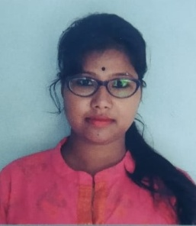
CAREER OBJECTIVE
To work with an organization having the good reputation of cultural and professional environment where I can utilize my skills .
PROFESSIONAL CAPABILITY
- Passion in the teaching field with a great teaching aptitude.
- Thorough knowledge in the subject along with its background.
- Excellent ability of implementing teaching methods and techniques to make the subject more apprehensible to the students.
- Uncommon ability to serve the subject by a fascinating and interesting way.
- Highly follows personal and working ethics.
ACADEMIC QUALIFICATION
EXAM PASSED | BOARD/UNIVERSITY  PASSED | YEARS OF  PASSING | PERCENTAGE  OF MARKS
B.Ed | CU | 2018 | 77.77
M.A | RBU | 2015 | 69.38
B.A (BENGALI HONS) | RBU | 2013 | 57.37
H.S | WBCHSE | 2010 | 72
Madhyamik | WBBSE | 2008 | 64.25
WORKING EXPERIENCE
Three years of professional experience in private teaching activity.
HOBBY
Reading story books , Listening music , Writing prose , Art and Painting .
PERSONAL DETAILS
NAME PAYEL MAJI
DATE OF BIRTH 9TH MAY, 1993
NATIONALITY INDIAN
MARITAL STATUS SINGLE
LANGUAGES KNOWN BENGALI, ENGLISH
RELIGION HINDU
CATEGORY GENERAL
PRESENT ADDRESS VILL- KANTILABAR P.O+ P.S – SHYAMPUR ,
DISTRICT - HOWRAH PIN – 711314
MOBILE NO 8001005827
REFERENCE AVAILABLE ON REQUEST

ABOUT MYSELF
# I am very hard working ; always ready to face new challenges with full of confidence and very keen to learn and to do experiment with new project.

# Ready to take up challenging job with full responsibility, sincerity and able to adapt new environment easily.

DECLARATION
I PAYEL MAJI hereby declare that the above information furnished by me is true and correct to the best of my knowledge. In any event if any of the information found incorrect/ false detected in the selection procedure, my candidature will be automatically cancelled.
DATE :
PLACE : Howrah

Signature of the Candidate

