CURRICULAM VITAE

NAME – SAURAV KUMAR SINGHA
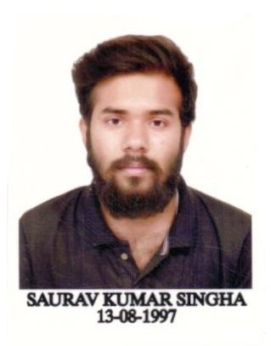
FATHER’S NAME – LATE RABINDRA KUMAR SINGHA
DATE OF BIRTH – 13/08/1997
RELIGION- HINDU
SEX- MALE
CATEGORY- GENERAL
ADDRESS – KRISHNAPALLY BAPUJI COLONY,MALDA
DIST - MALDA
PIN – 732101
Mobile: +91-9064957336/8942977624
Email ID – sauravkrsingha97@gmail.com

EDUCATIONAL QUALIFICATIONS:
- TECHINAL
Examination | Board/Council | College | Year of passing | Grade point average
B.TECH  (ELECTRICAL ENGINEERING) | MAKAUT | IMPS COLLEGE OF ENGINEERING & TECHNOLOGY | 2020 | 7.0  (up to 6^{th semester} )
Diploma  (ELECTRICAL ENGINEERING) | WBSCTE | MALDA POLYTECHNIC MALDA | 2017 | 7.0 or 66.4
- NON TECHNICAL
Examination | Board/Council | School | Year of passing | Percentage of Marks
HIGHER  SECONDARY | WBCHSE | MALDA ZILLA SCHOOL | 2015 | 72%
SECONDARY | WBBSE | MALDA ZILLA SCHOOL | 2013 | 78.5%

- TRANINGS UNDERTAKEN
NAME OF INSTITUTION | TOPIC | DURATION
NTPC PVT LTD | VOCATIONAL TRAINING | 30 DAYS

- LANGUAGE KNOWN
1. ENGLISH
2. HINDI
3. BENGALI
- HOBBIES:
1. CREATIVE WRITING
2. READING(NOVEL,POETRY,SHORT STORIES)
3. TRAVELLING

I hereby declare that all the above statements made are true and correct to the best of my belief and knowledge. In the event of any information being found false or incorrect at any point of time my candidature may be cancelled without any notice.

Saurav kr singha

- PLACE : MALDA signature
(SAURAV KUMAR SINGHA)

