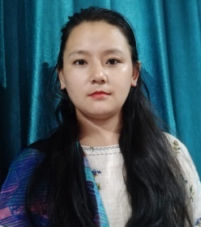
RESUME

NAME: ROSHNA RAI
EMAIL: roshnarai784@gmail.com
ADDRESS: DARJEELING, WB
CONTACT: 9800884849/7091565345

EDUCATIONAL QUALIFICATION
- Master in English from IGNOU
- Bachelor Degree from Darjeeling Govt. College
- Primary Teacher Training from Maharshi Dayanand University
- CTET cleared
TEACHING EXPERIENCE
- 10 years experience as a Primary English Teacher

PROFESSIONAL SKILLS
- Have an excellent communication skills to deliver the subject in an easy and effective way
- Have knowledge and utilizing the modern teaching aids such as computer assessing, Ms Words, presentation etc.
- Have a caring attitude towards individual child’s needs and concerns.
- Have a strong desire to work with children
- Have a potential to teach any subject in primary sections.
- Have a good experience as program coordinator

HOBBIES
- Learning new things

PERSONAL DETAILS

- DOB: 26.10.1989
- GENDER: FEMALE
- MARITIAL STATUS: MARRIED
- LANGUAGE KNOWN: HINDI, ENGLISH AND NEPALI

DECLARATION

I hereby declare that all the above information is true to the best of my knowledge.

