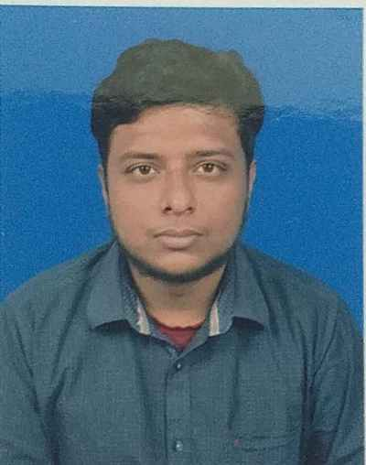
Pratik Jha
Passionate, Enthusiastic, Confident

Academics –

- L.M.S.M.H.S (Malda,WB) Personal details-
- Secondary(10th) DOB- 30th aug 1997
- Year-2014 Sex-male
- Percentage-73.14 Caste- Hinduism

- A.C.INSTITUTION,HS (Malda,WB) Languages-
- Higher Secondary(12th) 1.Bengali(Mother tongue)
- Year-2016 2.English(Speak,read,write)
- Stream-Arts 3.Hindi(Speak & read)
- Percentage-77.80

3.GAZOLE MAHAVIDYALAYA(Malda,WB) Skills
- Bachelor of Arts(B.A) Passionate
- Year-2019 Enthusiastic
- Honours in English Literature Fast learner
- Percentage-50.62 Communication skill
Time management
- UNIVERSITY of GOUR BANGA (Malda,WB) Team management
- Master of Arts(M.A) Confident
- Year- 2021 Friendly
- Masters in English language & literature Tolerant
- Percentage-58.58 Calm

Additional qualifications Hobby & Interest
Diploma at computer application(DCA & DIT) 1. Writing articles
Typing speed-35wpm 2. Reading literature
3. Cooking
4. Giving Honorary tuition

Contact details
Address-North sunnypark,Malda(WB)
Malda- 732101
- Mobile-7001947216
- Email- pratikjha80@gmail.com
- Whatsapp-9735796373

“I Pratik Jha hereby declare that all the information provided by me is correct, true and valid. I will present the supporting documents as and when required.
Pratik jha
Date- 22.01.23

