CURRICULUM VITAE
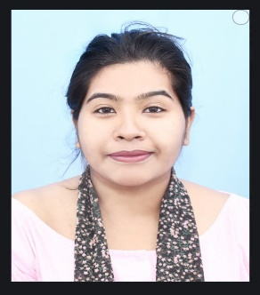 Maumita Debnath
Date of Birth :17/04/1996
Nationality: Indian
Sex: Female
Marital Status: Unmarried
Father’s name: Rakhal Debnath
Mother’s name: Pratima Debnath
Contact No: 8918110536
8918790832
Email: maumitadebnath2023 @gmail.com
Educational Qualifications:

Qualification (S) | Name of the University/Institute | Year of Passing
Mlib.sc | North Bengal University | 2022
M.A(Rural Development) | North Bengal University | 2020
Blib.sc | North Bengal University | 2018
B.A (History) | Sital khuchi college | 2017

Address for Communication:
Residence At-
Vill- Nagar shova ganj
Post-Bara gadai khora
Ps: Sital khuchi
Dist.: coochbehar
Pin: 736172
Present address -
2 No. Govt. Colony
Near Ramkumar Balika Vidyalaya
P.o - Mokdumpur
P.s - English Bazar
Dist. - Malda, Pin - 732101, West Bengal

WORKING EXPERIENCE:
1: Working as an intern at North Bengal University I was completed three month of internship programme at the university library in the session 2021-2022s a part of MLIS course.

2: Working with (IKONET RESEARCH & CONSULTANTS PRIVATE LIMITED) as a Quality Control associate in our various social research projects and associated in project specific assignments pertaining to data validation and data collection on CATI platform since 1st August 2020 to till now.

RESEARCH EXPERIENCE:
● Dissertation on: Youth Unemployment in coochbehar district (M.A).
● Dissertation on Application on social media on library services: A case study on North Bengal University (MLIS)

Participate in Seminar/ Conferences:
● Participated in National Seminar on Social implications of library & information science: Descriptive & prescriptive approaches on 14th -15th march, 2017 at North Bengal University.
● Participated in the 63rd All India Adult Education Conference jointly organized by Indian Adult Education association (IAFA) on 27rd - 29rd November ,2018 at North Bengal University.

Research Area/Area of Interest:
● College library/University Library (Digital library)
● Social research.

Courses under Taken:
• Information Technology Application.
• Office Management.
Disaster management.

Skills and Knowledge Areas:
● Work experience: Applications: Windows, 7 ,10 ,11 Basic computering Software: M.S. office, MS word, MS Excel, MS ppt.
● Survey Software : Survey to go.

Maumita Debnath

