RESUME
NAME :PARUL CHOWDHURY
FATHER’S NAME:RANJIT CHOWDHURY
DATE OF BIRTH:01/01/1995
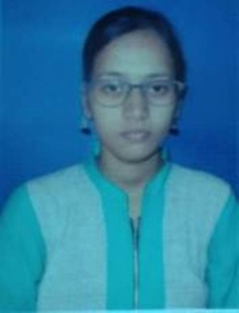
ADDRESS:
VILL.KALITALA 1ST LANE
PO.MOKDUMPUR
PS.ENGLISH BAZAR
DIST.MALDA
PIN-732101
WEST BENGAL
CONTACT No.8250148737
E-MAIL:parulchowdhury2015@gmail.com
EDUCATIONAL QUALIFICATION:
EXAM PASSED | NAME OF INSTITUTION | NAME OF BOARD | YEAR | MARKS(%)
MADHYAMIK | MALDA BARLOW GIRLS HIGH SCHOOL | WBBSE | 2010 | 67.5
HIGHER SECONDARY | MALDA BARLOW GIRLS HIGH SCHOOL | WBCHSE | 2012 | 70
B.A(ENGLISH HONS.) | MALDA COLLEGE | UNIVERSITY OF GOUR BANGA | 2015 | 46.5
B.ED | VIVEKANANDA TEACHERS TRAINING COLLEGE | UNIVERSITY OF GOUR BANGA | 2017 | 74.85

OBJECTIVE: To encourage creativity and higher-order thinking in a way that increases student performance.
EXTRA QUALIFICAFION:
1 Year diploma in computer application.
HOBBIES:Cricket And Traveling.
LANGUAGE KNOWN:BENGALI, ENGLISH, HINDI.
NATIONLITY: Indian
RELIGION: Hinduism
CASTE: SC

Date:……………… Signature
Place:……………...

