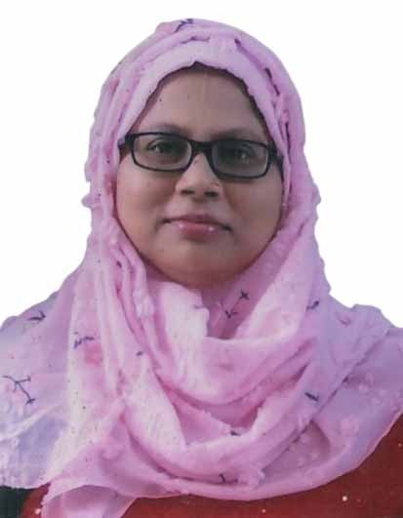

MOBILE- 8906618596

EMAIL ID:
rehana.zahin@gmail.com

ADDRESS:
VILL-72/224 Maheshmati
(Beside Jingle Bell School)
P.O- Malda
P.S- English Bazar
Dist- Malda
Pin- 732101

CURRICULUM VITAE

NAME : REHANA SULTANA

CAREER OBJECTIVE
With my abilities and hard work I would like to get a respected job which will fulfil my financial need & ensure a healthy work environment as well.

WORKING EXPERIENCE

- Worked as a teacher (Bengali) at KOCHI KACHA MISSION , Jadupur , Malda for 2 years.

EDUCATION BACKGROUND

Exam Name | Board/  University | Year of Passing | Marks Obtain | Total Marks | Percentage
MP | W.B.B.B.E | 2002 | 531 | 800 | 66.38 %
H.S | W.B.C.H.S.E | 2004 | 1000 | 495 | 49.50 %
B.A (Beng. H) | N.B.U | 2009 | 438 | 800 | 54.75 %
M.A | U.G.B | 2011 | 912 | 1600 | 57 %
D.EL.ED , PTTI | VIDYASAGAR PTTI COLLEGE , D, DINAJPUR | 2012 | 864 | 1100 | 78.55 %
D.EL.ED BRIDGE COURSE | SOVARANI COLLEGE OF EDUCATION | 2014 | 720 | 850 | 84.71
B.ED | U.G.B | 2013 | 613 | 1000 | 61.3 %

COMPUTE R KNOWLEDGE

- Basic knowledge in computer

EXTRA CARRICULAR ACTIVITIES

- Good reciter , Painting

PERSONAL DETAILS

Father’s Name : Md. Ilias
Gender : Female
DOB : 06/10/1986
Religion : Islam
Nationality : Indian
Marital Status : Married
Languages Known : Bengali, English & Hindi

Declaration: I hereby declare that all the information provided here is true to the best of my knowledge.
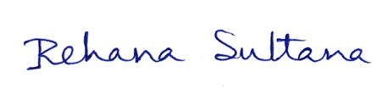
Place: Malda
Date:30.09.2023 Signature

