CURRICULUM VITAE
MONALISHA BHATTACHARYYA
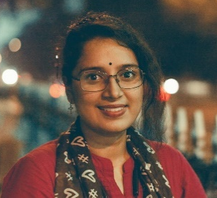
48, Thakurpara Road,
PO + PS – Purba Putiary, Regent Park,
District – Kolkata
Pin – 700093, West Bengal
E-Mail: monalisha.riya.bhattacharyya@gmail.com
Mobile: 7980368543, 9038514079

PERSONAL PROFILE
- Date of Birth : 2nd November, 1997
- Gender : Female
- Marital Status : Single/Unmarried
- Religion : Hinduism
- Nationality : Indian
- Languages Known : Bengali, Hindi, English and French
- Hobbies : Listening to music, Reading novels, etc.

ACADEMIC QUALIFICATIONS

Examination Passed | Year of Passing | Board/ Council/ University | Percentage | Division/ Class
Madhyamik (10th std.) | 2014 | ICSE | 89% | 1st
Higher Secondary (12th std.) | 2016 | ISC | 78% | 1st
B.A. (English Honors) | 2019 | Calcutta University | 49% | 2nd
M.A. (English) | 2021 | Calcutta University | 59.9% | 2nd
B.Ed. (English)(Appearing) | 2023 | WBUTTEPA | Appearing | Appearing

EXPERIENCE
- PGT English Teacher, BBITPS(CBSE): August, 2021 - Present
- Secondary School English Teacher: August, 2021 – December, 2021
- UKG Class Teacher and Primary School English Teacher: December, 2021 – Present

SKILLS & CERTIFICATIONS
- Basic computer knowledge/skills (Windows, MS-WORD, MS-EXCEL, INTERNET, E-MAIL).
- English For Career Development Course from Coursera under University of Pennsylvania.
- Communicative French from Ramkrishna Mission School of Languages.
- In-House Workshops Attended:
- POCSO
- National Curriculum Framework 2022
- Peace of Mind
- Next Learning Education
- Workshop on Innovation
- Nalanda Learning Platform
- Tinker Workshop
- Phonics Workshop
- CBSE Training Duration: 40+ hours. Please find notable courses below
- Experiential Learning course by CBSE
- Competency based education module 1,2,3,4
- Artificial Intelligence Appreciation

DECLARATION
I hereby declare that all the aforesaid statements are true to the best of my knowledge and belief.

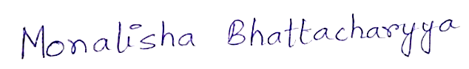
Date: 22 November 2022
Place: Kolkata (MONALISHA BHATTACHARYYA)

