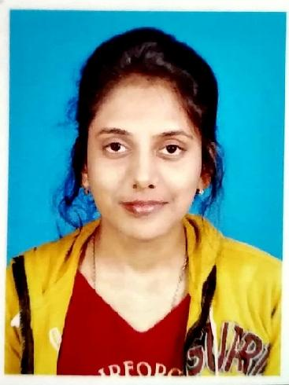
Debolina Dutta Chowdhury
Gender: Female
Mobile no. 8391869835/ 9474638505
E-mail id- tinniduttachowdhury@gmail.com

Academic details
Degree | Board/University | Year of passing | Subjects/Stream | Percentage
B.ed | WBUTTEPA | 2022 | Geography | 84.15%
M.sc | University of kalyani | 2020 | Geography | 74.81%
B.sc | University of kalyani | 2018 | Geography | 69.75%
Higher secondary | WBCHSE | 2015 | Arts | 89.2%
Matriculation | WBBSE | 2013 | All | 84.28%

Personal information
Father’s name: Sushanta Dutta Chowdhury
Mother’s name: Nanda Dutta Chowdhury
Date of birth- 14/09/1996
Address: Rathbari Prantapalli Malda, Pin.732101, P.s- English bazar Dist.Malda
Nationality:- Indian
Religion: Hindu
Caste: General
Marital status: Unmarried
Language known: Bengali, English, Hindi
Experience: Total 1 year 1 months of teaching experience.
7 months of teaching experience in an English medium school in Islampur and 6 months of teaching experience in an English medium school in Simurali, Kalyani.
2 years experience as a subject matter expert in bartleby private limited.
WB TET 2022 qualified
CTET paper 1 qualified in 2023.

