CURRICULAM VITAE
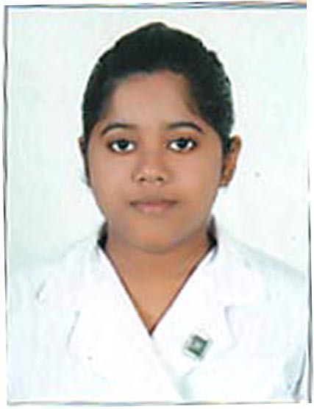

The following particulars are furnished in favor of my candidature:

NAME : SHIRSA DAS (GHOSH)

FATHER’S NAME : Mr. SAILENDRA NATH DAS

MOTHER’S NAME : Mrs. RAKHI DAS

ADDRESS : D-33 , SARADA PARK ,BIREN ROY ROAD (WEST),
P.O – SHIBRAMPUR, P.S.- MAHESHTALA,
KOLKATA – 700141

TELEPHONE NUMBER : 9875670299

E-MAIL ID : shirsadas.2013@gmail.com

PERSONAL INFORMATION :

DATE OF BIRTH : 17 – 10 – 1994
DD – MM – YYYY
SEX : FEMALE

MARITAL STATUS : MARRIED

NATIONALITY : INDIAN

LANGUAGES KNOWN:

 | ENGLISH | HINDI | BENGALI
SPEAK | YES | YES | YES
WRITE | YES | YES | YES
UNDERSTAND | YES | YES | YES

EDUCATIONAL QUALIFICATIONS
I have graduated in Bachelor of Arts (B.A) English Honours degree course of Calcutta University, from Shri Shikshayatan College, 11 Lord Sinha Road, Kolkata – 700071. I have completed my Masters(M.A) in English from Shri Shikshayatan College (C.U).
SERIAL  NUMBER | YEAR |  | EXAMINATION |  | CLASS |  | BOARD / UNIVERSITY |  | SCHOOL/ COLLEGE |  | PERCENTAGE OF MARKS
1 | 2011 |  | All India Secondary School Certificate Examination |  | 10 |  | Central Board of Secondary Education, Delhi |  | G.S.S Girls’ School |  | 80%
2 | 2013 |  | All India Senior School Certificate Examination |  | 12 |  | Central Board of Secondary Education, Delhi |  | Ashok Hall Girls’ Higher Secondary School |  | 89.25%
3 | 2014 |  | B.A. Part – 1 (Three Years Honours ) Examination |  | 1st year |  | University of Calcutta |  | Shri Shikshayatan College |  | 55%
4 | 2015 |  | B.A. Part – 2 (Three Years Honours ) Examination |  | 2nd year |  | University of Calcutta |  | Shri Shikshayatan College |  | 56%
5 | 2016 |  | B.A. PART-3 (THREE YEARS HONOURS) EXAMINATION |  | 3RD YEAR |  | UNIVERSITY OF CALCUTTA |  | SHRI SHIKSHAYATAN COLLEGE |  | 49.25%
6 |  | 2017 |  | M.A. PART-1 |  | 1ST YEAR |  | UNIVERSITY OF CALCUTTA |  | SHRI SHIKSHAYATAN COLLEGE |  | 52%
7 |  | 2018 |  | M.A.PART-2 |  | 2ND YEAR |  | UNIVERSITY OF CALCUTTA |  | SHRI SHIKSHAYATAN COLLEGE |  | 56%
8 |  | 2019 |  | B.ED |  | 4TH  SEMESTER (FINAL YEAR) |  | UNIVERSITY  OF CALCUTTA |  | SHRI  SHIKSHAYATAN  COLLEGE |  | 84.9%( till 3rd semester)

JOB EXPERIENCE
- Worked as a Class Teacher and English Teacher in B.D MEMORIAL INTERNATIONAL SCHOOL (VIJAYGARH BRANCH) from 27.8.2018 to 5.6.2019.

ACHIVEMENTS
- Senior Diploma in Fine Arts in the year 2001 and 2002.
- Secured First Division in Bharat Natyam Dance in the year 2004 and 2005.
- Secured First Division in Painting in the year 2004.
- Secured 10th position in Art Exhibition in the year 2003.
- Participated in Hyundai Sketch The I Competition.
- Obtained a certificate in Interior Designing from Birla Institute of Liberal Arts and Management Science.
- Participated in Poster Making (Vidyasagar Diwas) in the 2014.
- Participated in the Seminar held at Shri Shikshayatan College in the year 2015.
- Secured 57.33% in Sociology and 58% in Political Science from University of Calcutta in the year 2015, studied throughout class 11 and 12.

EXTRA – CURRICULAR ACTIVITIES
- Painting at free time.
- Reading story books.
- Swimming at leisure.

---------------------------------------------------------------------------------------------------------

