BIO DATA

Name : Bolram Barman
Father’s Name : Bijoy Barman
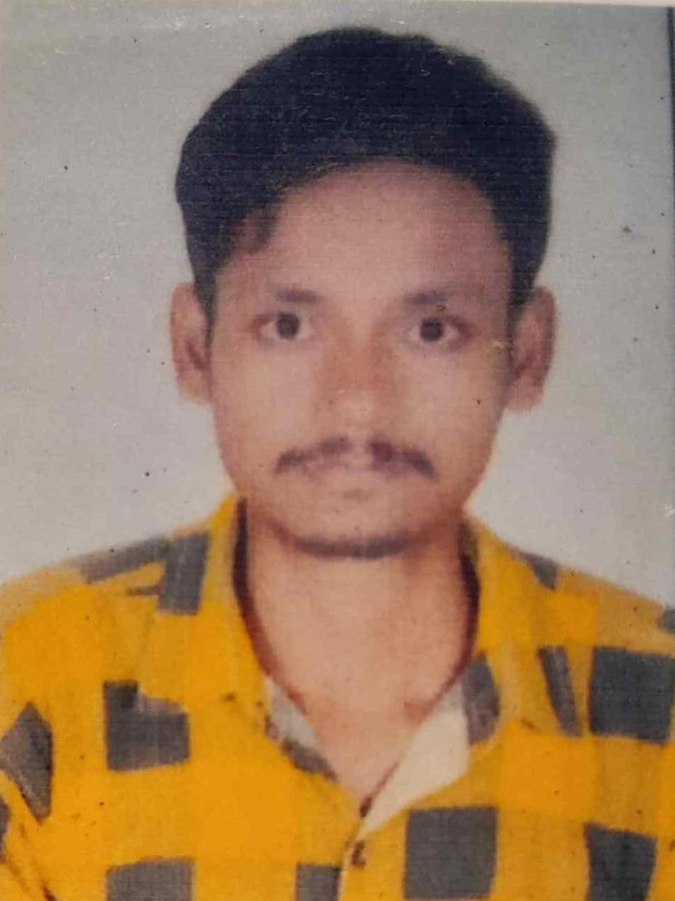
Date of Birth : 05/02/2000
Address : Vill – Shanti Colony
P.O - Kaliyaganj
P.S – Kaliyaganj
Dist – Uttar Dinajpur
Pin – 733129
State – West Bengal
Marital Status : Unmarried
Mobile No : 8918879265
Email Id : bolrambarman701@gmail.com
Cast : Schedule Cast
Category : Rajbanshi
Religion : Hindu

Examination | Board / University | Year of Passing | Percentage | Stream
Secondary | WBBSE | 2015 | 64.5%
Higher Secondary | WBCHSE | 2017 | 82% | Arts
B. A (Honours) | University Of Gour Banga | 2021 | 66.5% | Arts
Master in library and Information Science | University Of Gour Banga | 2023 | 66.31% | Social Science
Declaration : I hereby declare that all the information provided here is true to the best of my knowledge.
Date:
Place:
Signature

