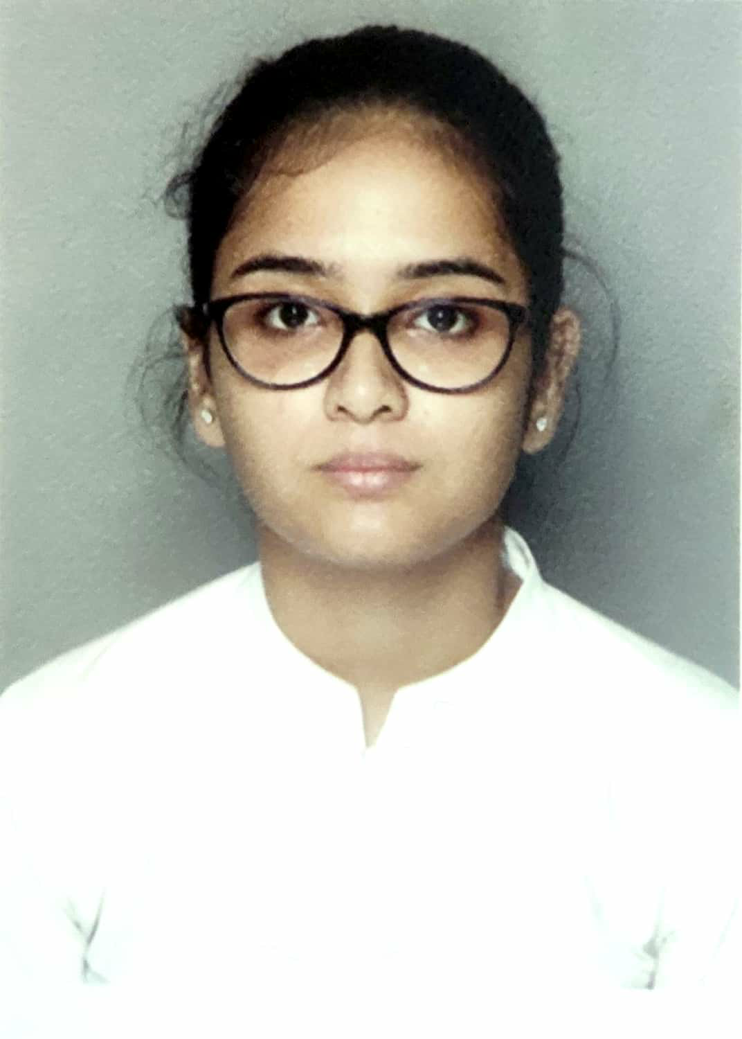
CURRICULUM VITAE
NAME: Aishwarya Mukherjee
ADDRESS: Debayatan Apartment 3rd floor C2, North Singatala, K.J.Sanyal Road, Malda -732101
CONTACT NUMBER: 8250104692/9563207338
DATE OF BIRTH: 05/04/1996
CAREER OBJECTIVE: To work in your esteemed organization wherein I can apply my technical and communication skills.
WORKING EXPERIENCE: I have been worked in CALCUTTA PUBLIC SCHOOL BIDHAN PARK (KOLKATA) since April 2019 to March 2021.
EDUCATIONAL QUALIFICATION:
- Completed B.Ed course from Jogendra Rajkrishna college of Teachers Education under THE WEST BENGAL UNIVERSITY OF TEACHERS’ TRAINING EDUCATION PLANNING AND ADMINISTRATION.
2. Passed B.A(Hons) Part I, Part II & Part III in Bengali from Bethune College under CALCUTTA UNIVERSITY with a percentage of Part I 63, Part II 61, Part III 59
3. Passed Higher Secondary examination from Barlow Girls' High School with a percentage of 86 in 2015
4. Passed Madhyamik examination from Barlow Girls' High School with a percentage of 72 in 2013
EXTRA CURRICULAR ACTIVITIES:
1.Completed Rabindra sangeet 5th year in 2015 & Najrul Geeti 5th year in 2017 from "Bangiya Sangeet Parishad".
2.Best Talent award in Rabindra sangeet in 2015 with Gold Medal from BETHUNE COLLEGE.
3. Completed 5th year in Bharatnatyam with Gold Medal from "Nikhil Bharat Sangeet Samiti" in 2015
4. Completed 3rd year in Recitation in 2010 from Sarbabharatiya Sangeet O Sanskriti Parishad.
CO CURRICULAR ACTIVITIES:
1. Drawing
PERSONAL DETAILS:
Husband’s NAME: Animesh Banerjee
NATIONALITY: Indian
LANGUAGES KNOWN: Bengali, English, Hindi
COMPUTER PROFICIENCY: Basic CITA
STATEMENT:
The above information given are true to my knowledge and I am solely responsible for any kind of fallacy in it.
DATE: 26th of September, 2023
(Aishwarya Mukherjee)
PLACE: Malda

