Resume
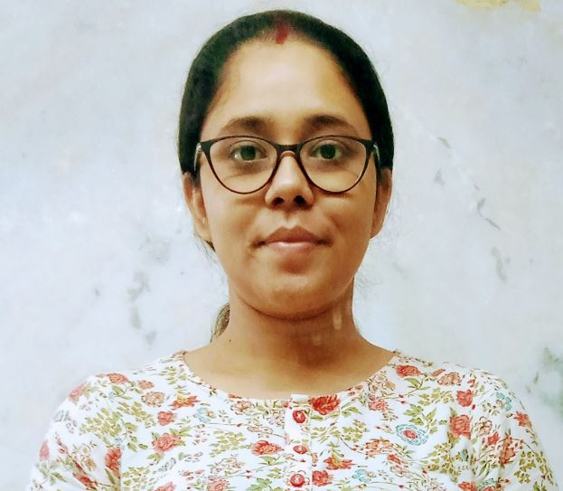
Puja Bhattacharjee
Mobile No. 9836576732
Email: officialpuja90@gmail.com

Career Objective:

To secure a promising position in an organization where I can get exposed to opportunities to learn, grow and prove my potential to achieve betterment of my own and people around as well.

Educational Qualifications:
- D.El. Ed -West Bengal Board of Primary Education; 2020 -2022 (82%)
- Master of Arts: Archaeology - University of Calcutta; 2010-2012 (55%)
- Bachelor of Arts (H): Sanskrit - University of Calcutta; 2007-2010(49%)
- Higher Secondary: W.B.C.H.S.E.; 2007(69%)
- Secondary: W.B.B.S.E.; 2005; (68%)

Employment Details:

Greenfield Academy, Rajarhat, Kolkata

12th April 2021-7th Feb 2022

Position: Assistant Teacher

Responsibilities:

- Responsible for students of standard VI & IV (as Class Teacher in two different sessions).
- Regular classes taken of multiple subjects [HISTORY & CIVICS (Class VII, VIII & IX), VALUE EDUCATION (Class VIII), ENGLISH LITERATUE & LANGUAGE (Class II, IV & VI]).
- Processing of Exam Papers & Marksheets.
- Conducting PTMs.

Chemex India

18th June 2018 – 7th January 2020

Position: Sales Co-ordinator

Responsibilities:

- Responsible for credit & collection of Kolkata Metro Distribution Branch for Tata Salt, Pulses, Soda & Detergent.
- Regular follow up with sales team & stockists as per sales portfolio.
- Maintaining follow up over mail to make every detail documented.
- Processing and generating reminder letters, bills, outstanding, monthly statements and claims.
- Use of SAP for Kolkata Metro to keep track on order range improvisation and growth.

Sabbatical (Feb 2017 – May 2018)

I was on sabbatical leave & left job to focus on studies for the civil services exam & during that time my father got a minor stroke, so I had to move back to my home town. There I used to provide tuitions to support my family

Chemex India

January 2015 – February 2017

Position: Sales Co-ordinator

Responsibilities:

- Visiting Stockists if required and maintain relationship with regular customer along with the TSIs.
- Supporting tele communication with mother company and stockists when require.
- Ensuring payment is collected in given time by customer.
- Investigating and resolving queries relating to non-payment of invoices.
- Order and dispatch flow check-ups and reporting on daily basis.
- Account reconciliation and complete documentation.

Employment Details: (Cont.)

Just Dial Limited

December 2013- July 2014

Position: Customer Service Executive
- Responsible for Customer Service of Kolkata Branch.
- Regular follow up with individual & business customer as per portfolio.
- Maintaining follow up over mail to make every detail documented.
- Meeting debtors if required and maintain relationship with regular customer.
- Supporting tele calling team & agencies as and when require.
- Lining up to Sales and Post Sales department to get the contract renewed.
- Ensuring smooth service in given time by customer.
- Processing and generating reminder letters and monthly statements.
- Investigating and resolving queries relating to existing and new customers.
- Legalizing with the sales team to resolve the outstanding queries.
- Account reconciliation.

Thinktel Solutions India Private Limited
December 2012 – July 2013
Position: Relationship Manager (Corporate Service)

Responsibilities:
- Meeting up with the client as SPOC on basis of accounts allocated.
- Maintaining relationship to retain them.
- Finding out customer’s challenges.
- Resolving the challenges with interpersonal skills & customer service skills.
- Coordinating with customers via mail on daily basis.
- Coordinating with concern team to get the update of all Service Requests.
- Looking after the Customer Service Request being done within SLA by concern team.
- Making sure customer gets proper reply for their requests and quarries via mail.
- Ensuring payment is collected in given time by customer.
- Update proper feedback to reporting manager on all accounts.

Certification and other technical knowledge:

- Diploma in Information Technology.
- MS Word Proficiency
- MS Excel

Core Competencies:

- Good Learner
- Dedicated
- Diligent
- Adaptable

Personal Information:

Date of Birth : 23.05.1990
Nationality : Indian
Gender : Female
Marital Status : Married (To Mr. Trideb Choudhury)
Permanent Address : 90, B.L Das Lane, English Bazar, Dist. -Malda, West Bengal. Pin-732101
Languages known : English, Hindi, Bengali.

