SAHEB BANSFORE
S/O. RAJKUMAR BANSFORE & LATE BULBUL BANSFORE
Curriculum VitaE

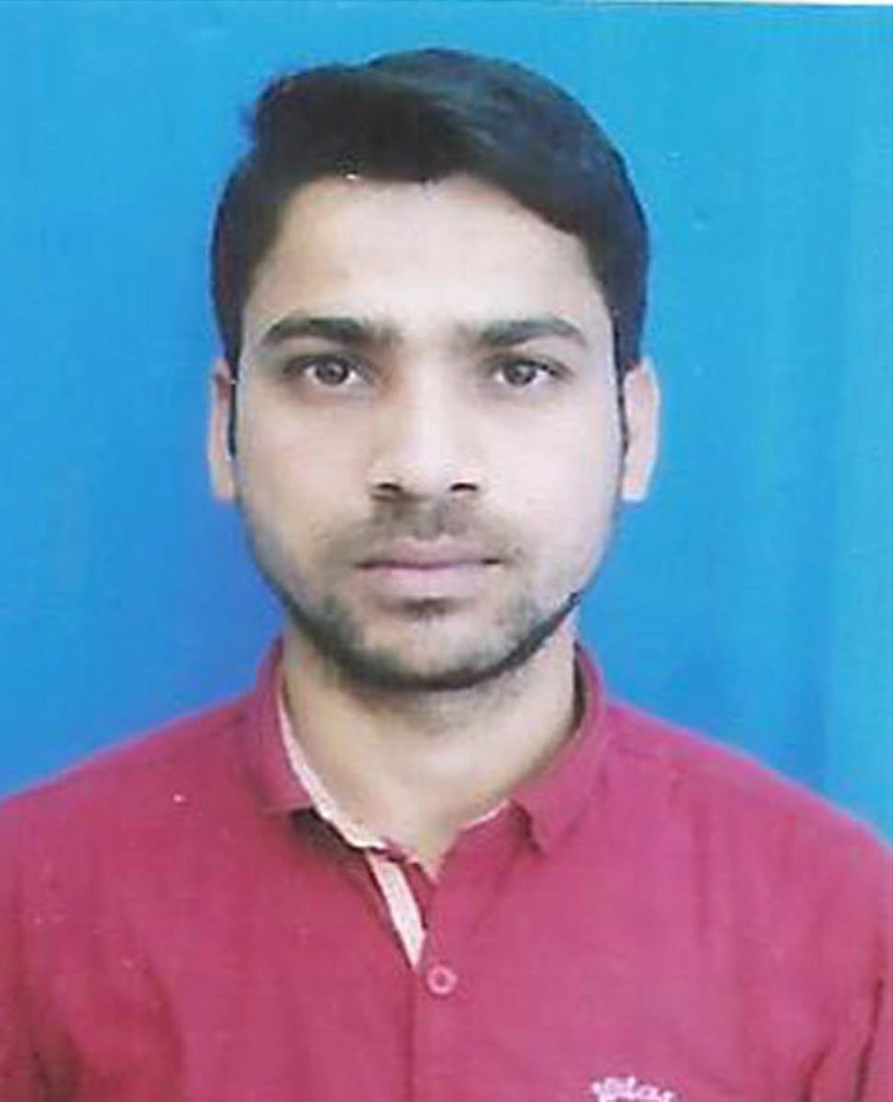

Contact
Contact No.: + (91) 8967813913/6294879767
E-mail : bansforesaheb819@gmail.com

Objective
To pursue a career that will provide me challenging and idealistic working environment for growth development it gets up with the organization and society.

Address
Present | Permanent
Kanirmore, P.O: Jhaljhalia  P.S: English Bazar,  Dist.: Malda, Pin: 732101 | Vill: Eklakhi, P.O: Rajadighi  P.S: Gazole  Dist: Malda, Pin: 732102

Personal Details
Date Of Birth  Gender  Nationality  Religion  Cast  Marital Status  Languages Known | :  :  :  :  :  :  : | 18th September, 1990  Male.  Indian.  Hindu  SC  Unmarried  Bengali, Hindi & English

Academic Qualification
Examination Name | Year Of Passing | Board/University | Percentage | Division
Secondary  Higher Secondary  B.A (English Hons.) | 2007  2009  2012 | W.B.B.S.E  W.B.C.H.S.E  U.G.B | 67.50%  67.50%  45.00% | 1st  1st  2nd

Computer Skill
- Completed Diploma in Computer Application.

Declaration
I hereby declare that the information furnished above is true to the best of my
knowledge and belief. If anything will false then I will be responsible.

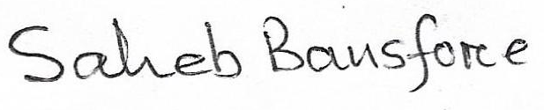

Date :
Place : Malda Signature

